# CS 340 README Template

*Use this template to complete your README file. When completing the template, keep the headings as they are so that your document has a clear organization. Remove the italicized prompt text after you have completed each section for a polished final document.*

## About the Project/Project Title

A rescue animal training company, Grazioso Salvare, aims to identify dogs that make good candidates for their search-and-rescue training programs. After these dogs are trained, they can rescue both humans and dogs from life-threatening conditions. In collaboration with animal shelters in Austin, Texas, Grazioso Salvare selects dogs for their training program. The Grazioso Salvare dog training program does have a specific profile they are looking for in dogs to train. With the help of this program, GS will be able to identify and categorize available dogs based on existing data from Austin animal shelters.

## Motivation

*Project goals include developing a fully functional and interactive web-based dashboard for an animal rescue training company. A Model, View, and Controller development pattern will be used for this project. -Model: This layer represents the underlying data/database used in development -View: This layer represents the user-facing visual representation. It handles communication between the user and the data requested (UI - User Interface). MongoDB is used as the database in this project. The view layer comprises Dash Plotly and Dash Leaflet, and the controller layer is composed of Python using Pymongo.*

*Tools Used:*

*MongoDB: The MongoDB NoSQL database solution offers speed, functionality, and robust querying features. The growing need for complex data structures resulted in the development of NoSQL databases. MongoDB and Python provide an easy way to build various database applications. This database system can store data in a variety of structureless formats. It also includes support for several different programming languages and is full of technical support and documentation. MongoDB has a Python driver, which gives it the full capability to produce an MVC pattern application using Python as the development language.*

*Dash Framework - Dash is a robust Python framework developed by Plotly for creating interactive web apps and data visualizations. It includes many pre-built components and tools that make it simple to build professional-looking applications with minimal coding. Web applications are built with this framework's view and controller structures. This framework provides data visualization interfaces as an open-source project. In addition, Python is supported, which allows for efficient development between views and controllers.*

*Python: Python is among the most popular high-level programming languages available today. Python and MongoDB, which provide flexible and dynamic schemas, allow for creating modern web applications, JSON APIs, and data processors. MongoDB provides an official Python driver called PyMongo. With PyMongo, you can communicate with a MongoDB server using various tools. Querying, retrieving results, writing and deleting data, and running database commands are all possible through this application.*

*Functionality:*

*A user-friendly interface and intuitive navigation make this application easy to use. As soon as you load the application, the Graziosos icon is red, linking to the SNHU page and displaying the dashboard's title. There is a row of buttons available for the user to select from. Four radio buttons are available for the user to interact with, and they can filter results based on Mr. Graziosos' preferences for the Dog's breed. The first button represents Water Rescue, the second button represents Mountain Rescue, the third button represents Disaster Rescue team, and the fourth button represents Reset. Under each button, you will find a data table compiled from the five animal shelters that provided the information, as well as the pie chart and geolocation chart for each. You can see a pie chart that illustrates the percentage of each breed used in the filters below. There is also a geo map that shows the current location of the animal selected in the data table.*

Filtering Requirements:

Filtering Requirements for Rescue Dogs

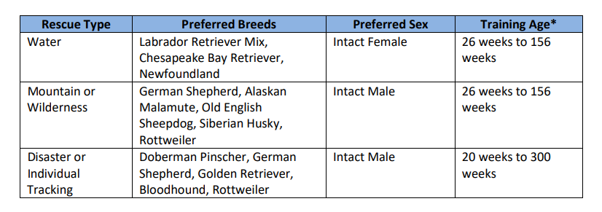

1. Opened the Project Two Dashboard.ipynb file, which contains the starter code for the dashboard and the authentication interface. Uploaded this file into Apporto and open it using the Jupyter Notebook application. Reviewed all the starter code provided, the import commands and the comments describing what each section of code does.

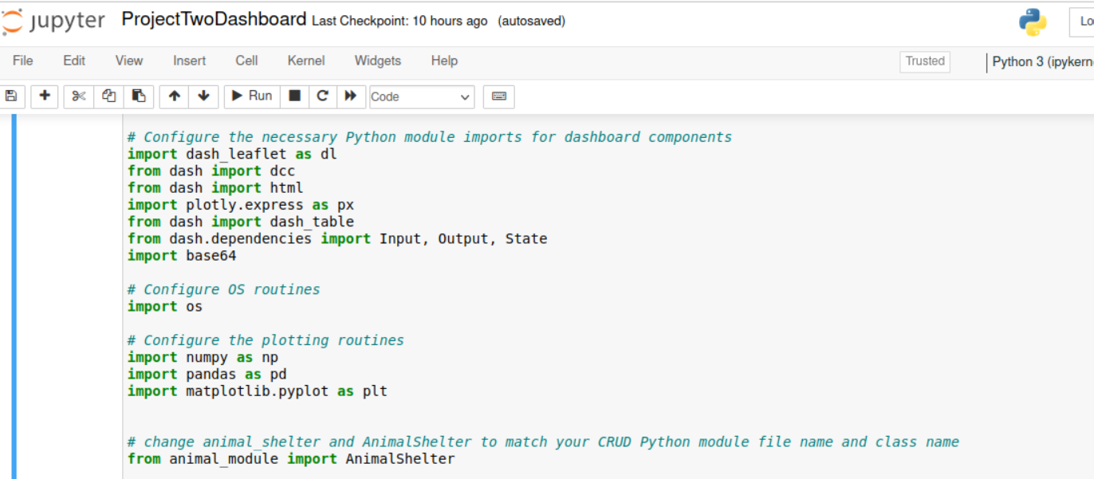

*2.The code that you have been given provides you with a very basic dashboard. Added an HTML component, such as a header, to create a unique identifier for your dashboard. This unique identifier could be your name or a specific handle or image that is unique to you. Imported the CRUD Module.*

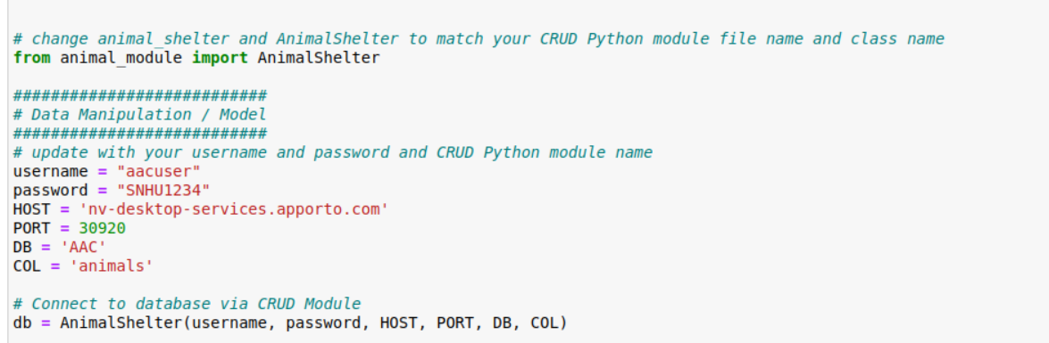

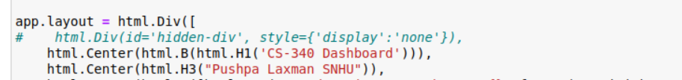

*Q. An explanation of the attributes and working functionality of the CRUD operations?*

*As shown in the provided screenshots, we can take C, for example, in CRUD (create(self, data)). The main benefit is that it allows the holding of data parameters as a new addition. Having the code return true or false allows the data to be inserted into the animal group.*

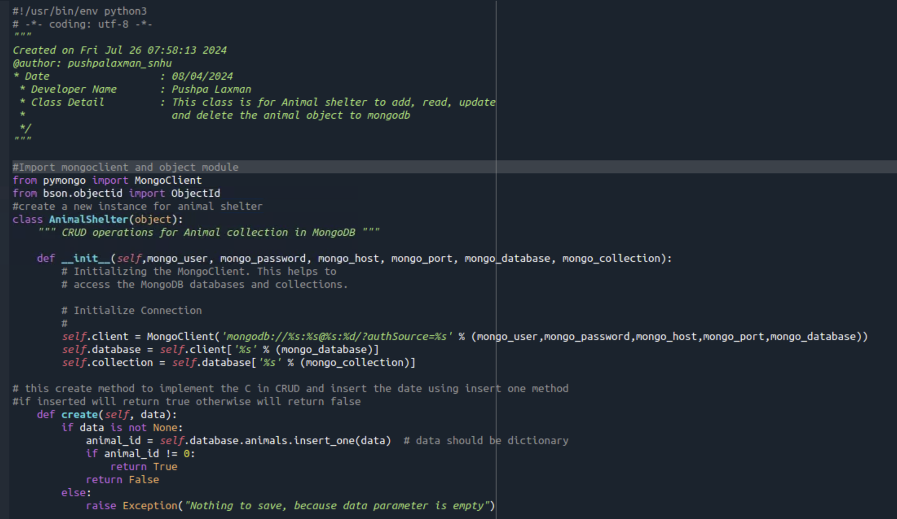

*You can find anything matching the information you entered using read for R. The database can be read over.*

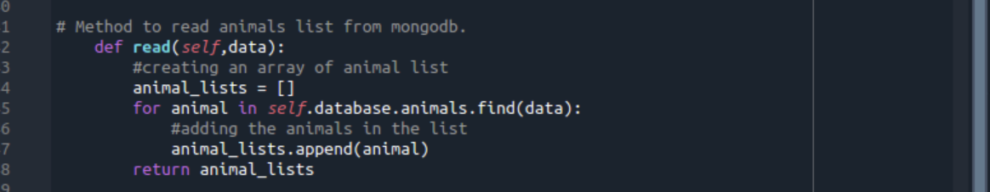

*U stands for update, which means updating the document's current data. Updates were just provided to the animal group.*

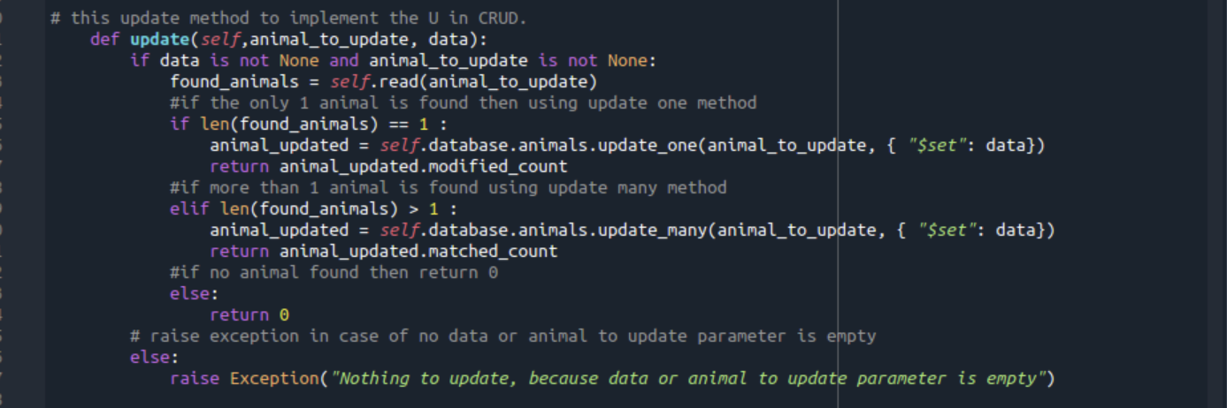

*Finally, D stands for delete in the CRUD family. If you need to remove information from the animals group or make any changes, you can do using delete method*

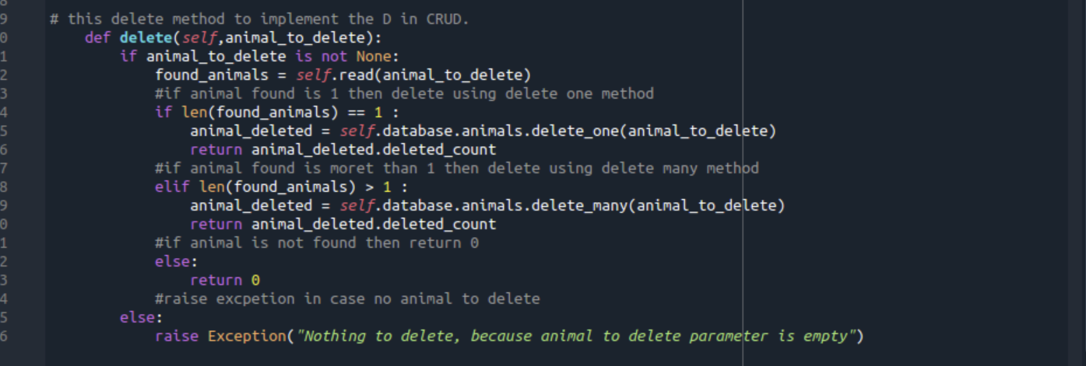

## Getting Started

* *Install MongoDB: Provide a link to the official installation guide.*

*https://www.mongodb.com/docs/manual/tutorial/install-mongodb-on-windows/*

* *Install Python: Follow the steps provided in the installation guide.*

*https://phoenixnap.com/kb/how-to-install-python-3-windows*

* *Install PyMongo: Use pip to install: pip install pymongo*

*https://pypi.org/project/pymongo/*

* *Install Jupyter Notebook: Use pip to install: pip install notebook*

[*https://jupyter.org/install*](https://jupyter.org/install)

* *Install dash frame*

*Dashboard .ipnyb file*

* *Ensure MongoDB is running and that you have the necessary authentication credentials.*
* *Download the necessary Python files and place them in the correct directory.*
* *cd /usr/local/datasets/aac_shelter_outcome.csv*
* */usr/local/datasets/*
* *Open the MongoDB terminal and import the aac_shelter_outcome.csv file into the AAC database and your local animals' collection within the local port using the Mongoimport tool.*

1. ***Screenshots of the MongoDB import execution. You took these screenshots in Step 1.***

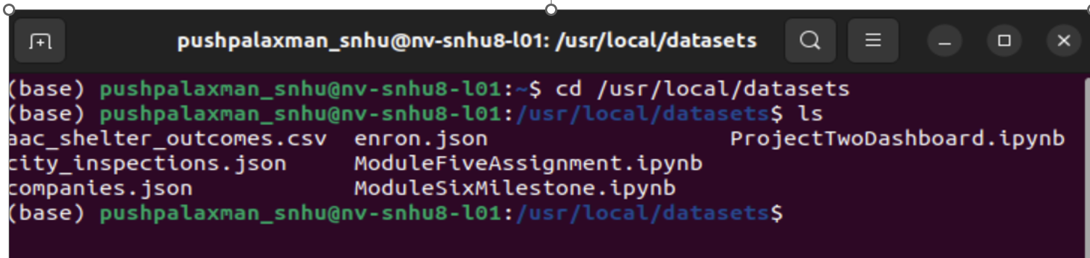

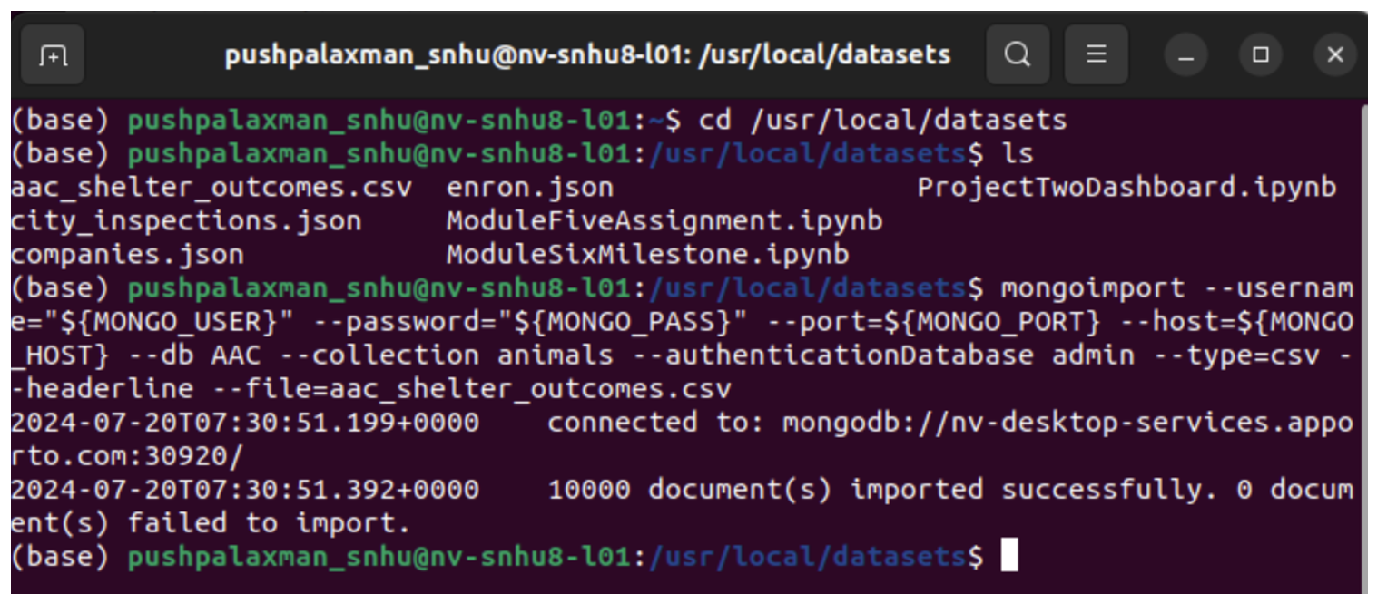

Login to mongodb via mongosh -Check the databases using the Show dbs command and checked the required AAC database.

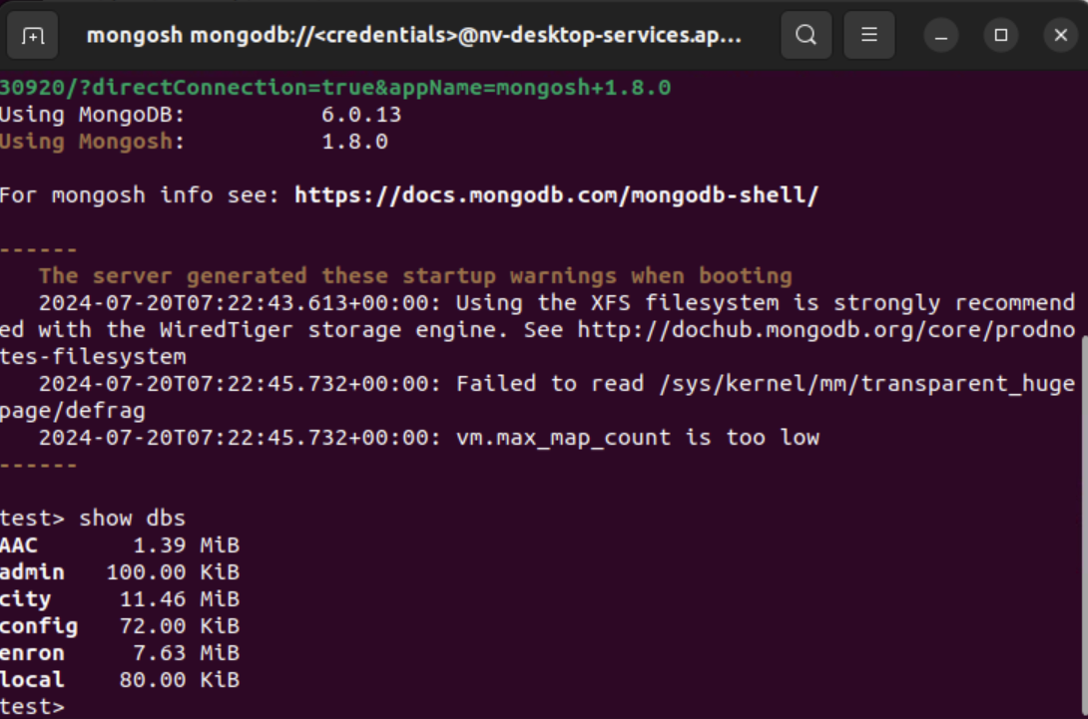

Switched to AAC database and the required collection animals

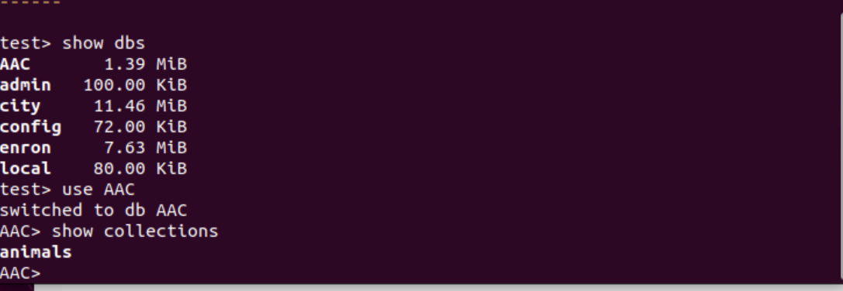

* *Organize the imported documents into an AAC database by creating simple and compound indices. I used the command createIndex for the breed field and checked the query planner using explain function*

*db.animals.createIndex({"breed": 1})*

*db.animals.find({"breed": "Domestic Shorthair Mix"}).explain()*

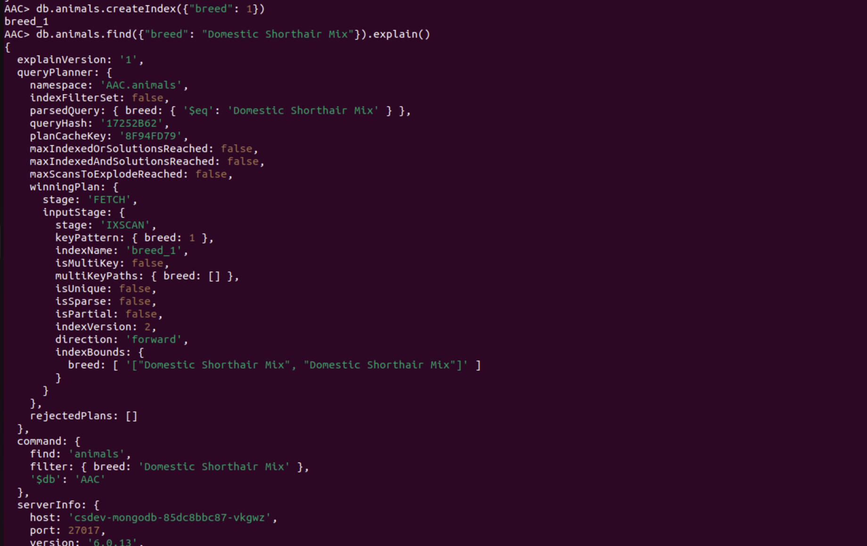

*I used command createIndex for breed, outcome_type, transfer. Also checked using the explain command with execution stats.*

*db.animals.createIndex({"breed": 1, "outcome_type": 1, "Transfer": 1})*

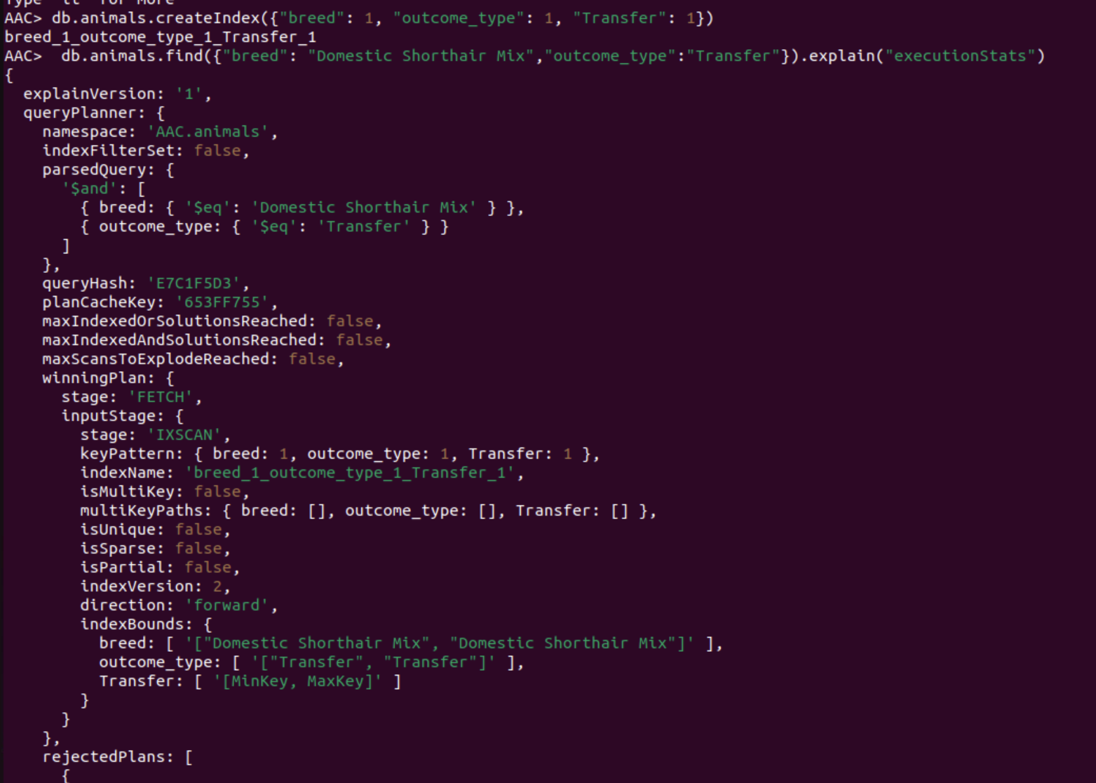

* *Set up an admin and user account in AAC.animals so that the user can read and write within the documents.*
* *Access the data via a MongoDB database with the appropriate user authentication (username and password)*
* *Authentication involves creating both an Admin account and an aacuser account for the user.*

***Q. Screenshots of the user authentication execution. You took these screenshots in Step 2.***

*Ensures User Authentication*

*Create Authentication: switched to the AAC database and created a new user named “accuser” with the below roles.*

*db.createUser({user: "accuser", pwd: "SNHU1234", roles: [{role:"readWrite",db:"ACC"},{role:"read",db:"test"}]})*

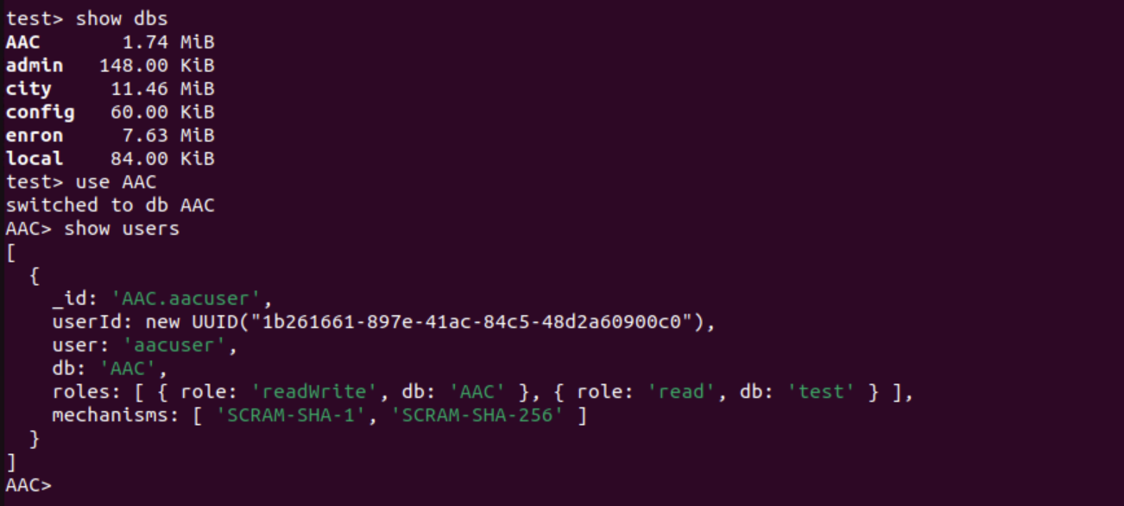



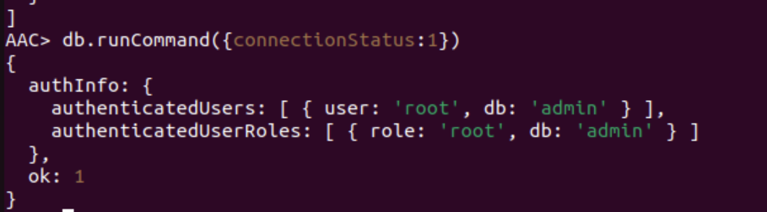

*Validating new user Authentication.*

*Used Two mongo terminals for admin and AAC accuser.Below screenshots is from both the terminals.*

*Executed the following command:*

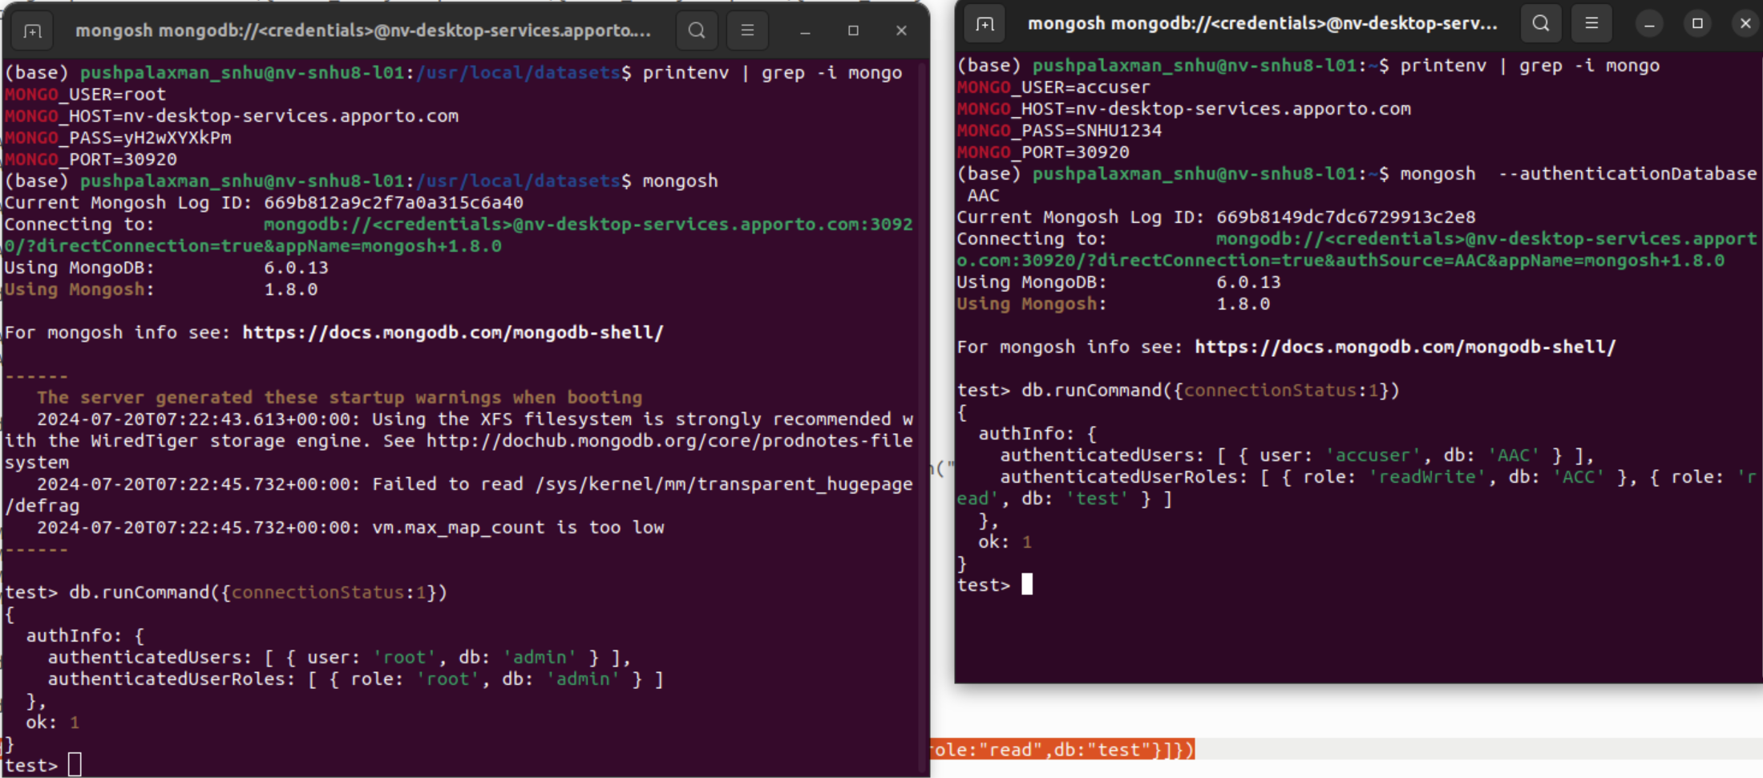

* *Finally, the user needs to have access to Python and run the program on a jupyter notebook.*

## Installation

* *A current version of Python to run both the .py and the .ipynb files MongoDB - to access the database.*
* *Jupyter Notebook is used to write and create ipynb files and run files to check the output of the files.*
* *Pymongo and Objectid are the libraries that I used.*
* *AnimalShelter was the CRUD Python I used.*
* *Install MongoDB: Provide a link to the official installation guide.*

*https://www.mongodb.com/docs/manual/tutorial/install-mongodb-on-windows/*

* *Install Python: Follow the steps provided in the installation guide.*

*https://phoenixnap.com/kb/how-to-install-python-3-windows*

* *Install PyMongo: Use pip to install: pip install pymongo*

*https://pypi.org/project/pymongo/*

* *Install Jupyter Notebook: Use pip to install: pip install notebook*

*https://jupyter.org/install*

*Animal_shelter.py*

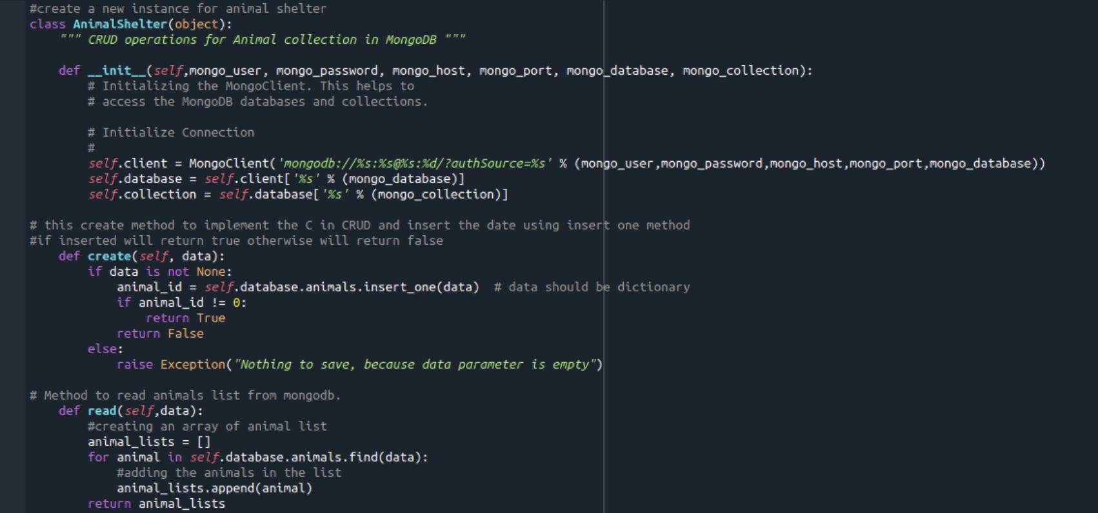

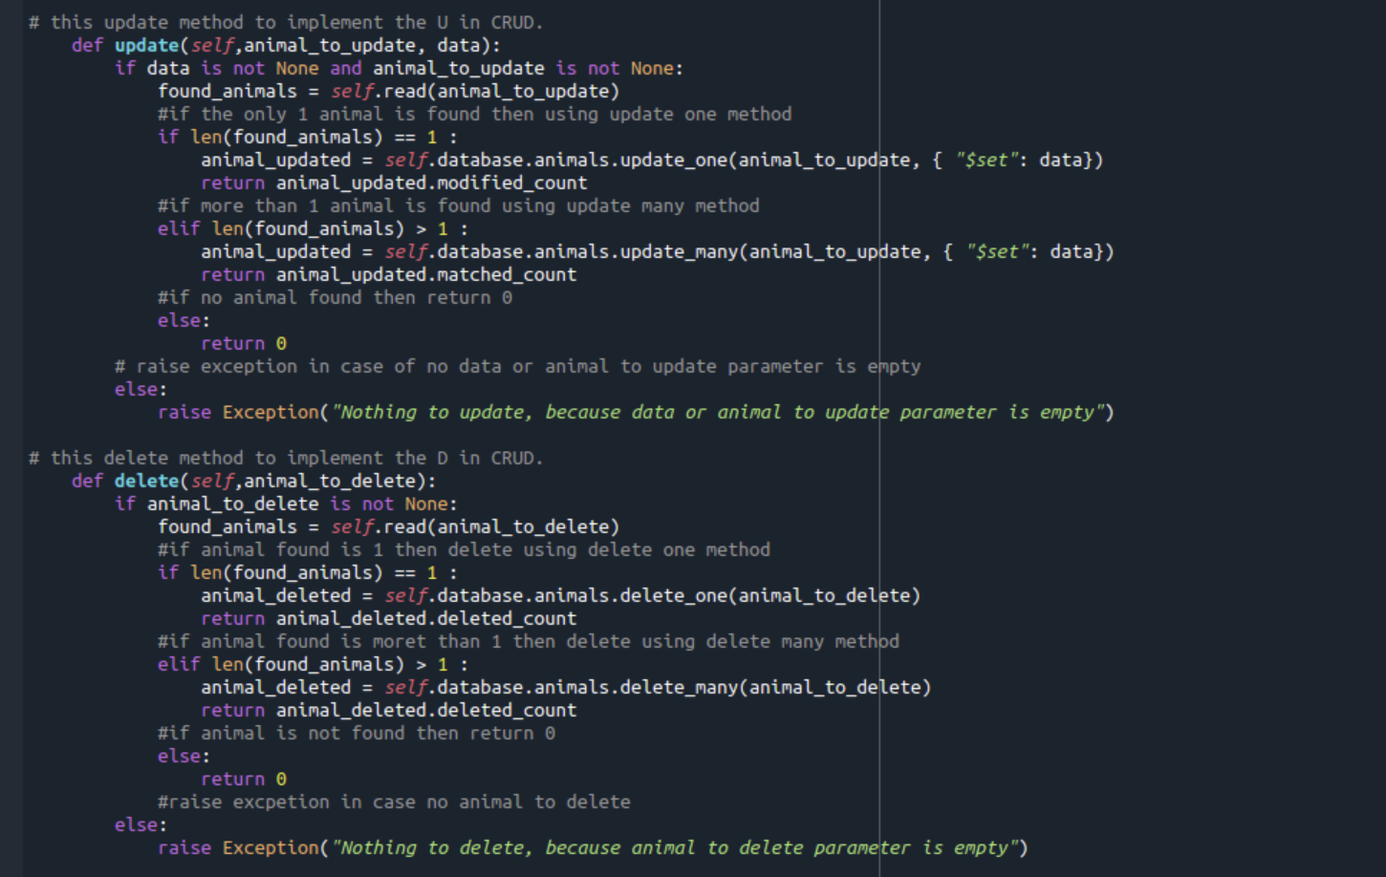

*Animal_main.py (Test script)*

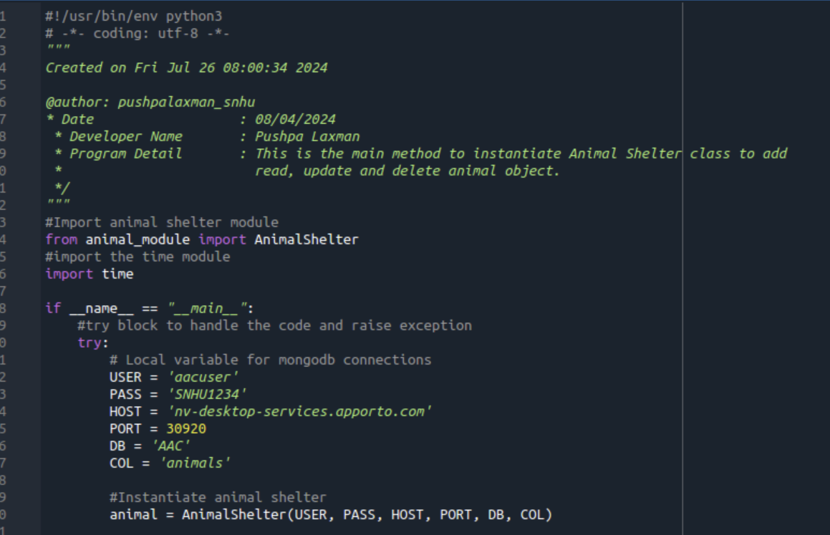

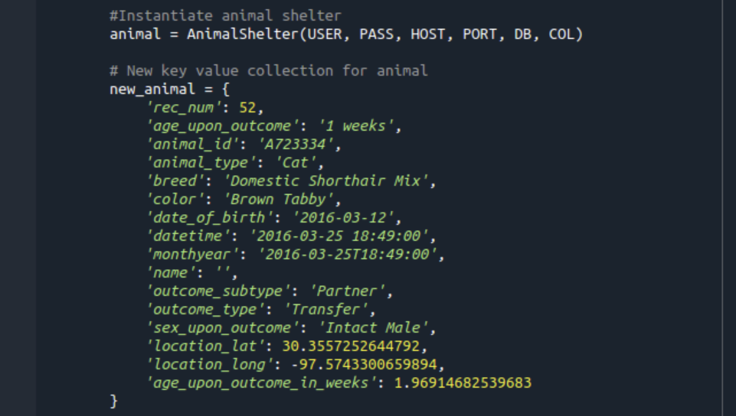

*# Insert using create method*

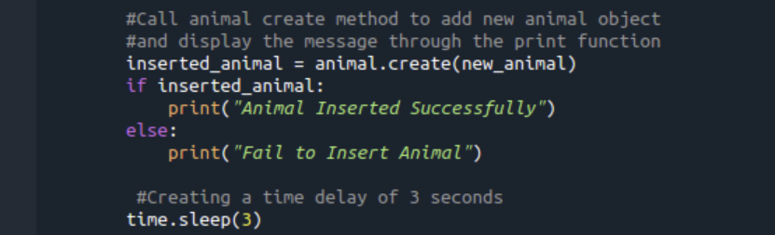

*# Now read using read command*

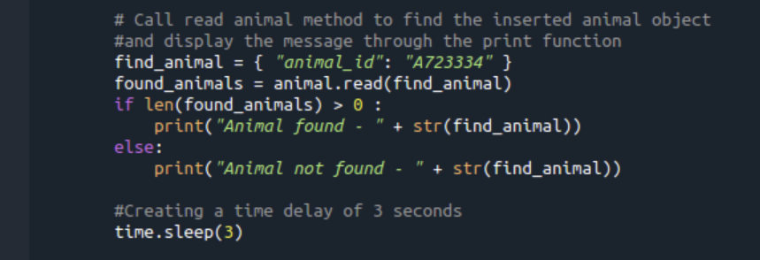

*# Update elements using update*

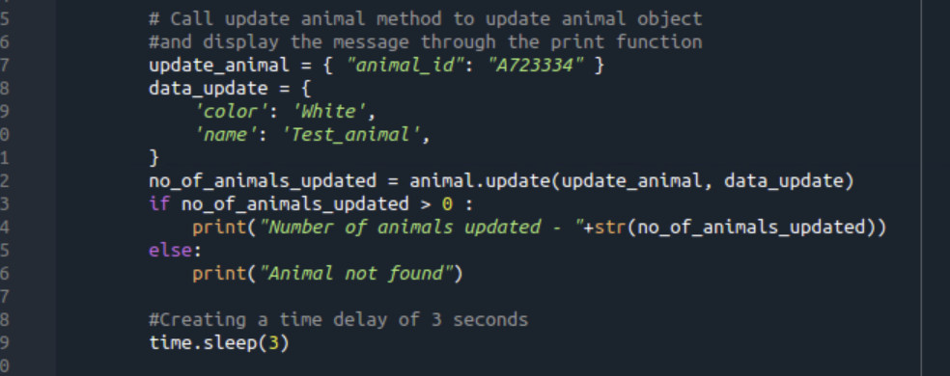

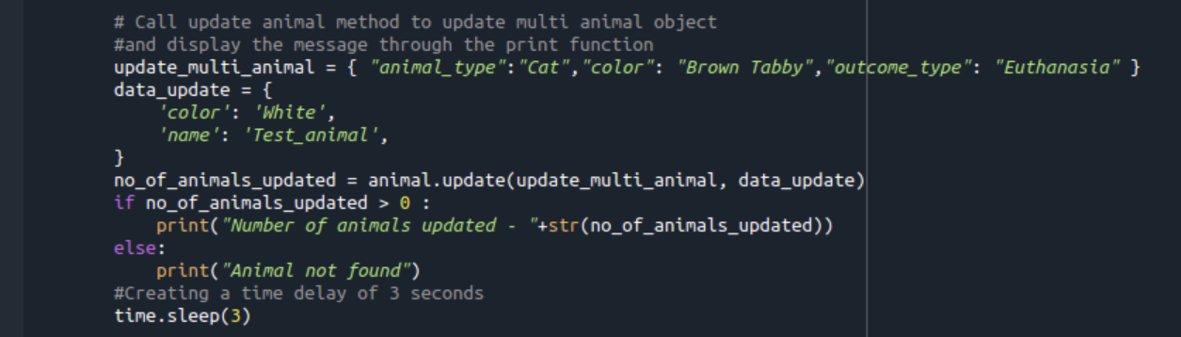

*# Now delete using delete command*

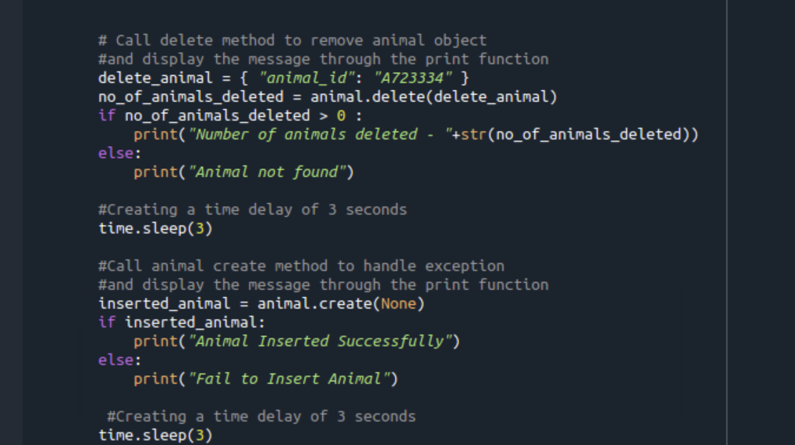

*Output*

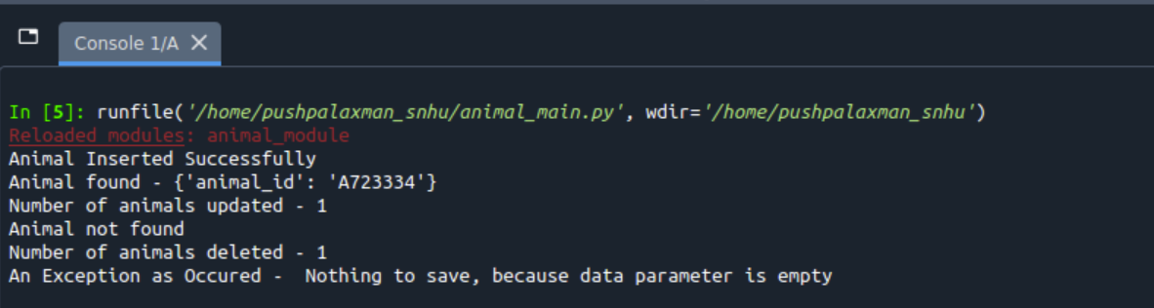

### Code Example

*Show what the library does as concisely as possible. Developers should be able to figure out how your project solves their problem by looking at the code example. Make sure that your code is short and concise.*

*Using the csv file in MongoDB and the program will help create and find animals in the database.*

*The "create" function uses the "insert_one" command in MongoDB to create a new animal.*

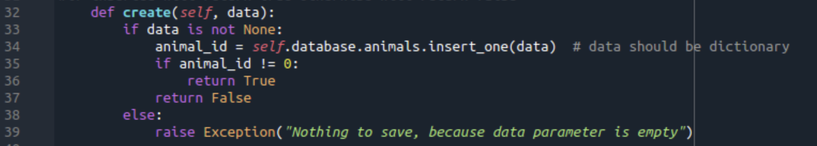

*The "read" function uses the "find" command in MongoDB to find the animal from the animal list*

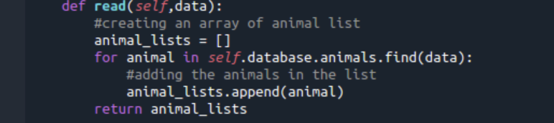

*The "update" function uses the "update_one" command in MongoDB to update a single animal whereas the “update_many” command updates many animals*

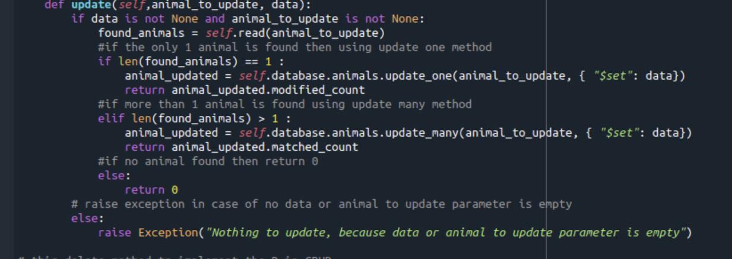

*The "delete" function uses the "delete_one" command in MongoDB to remove a single animal whereas the “delete_many” command removes many animals*

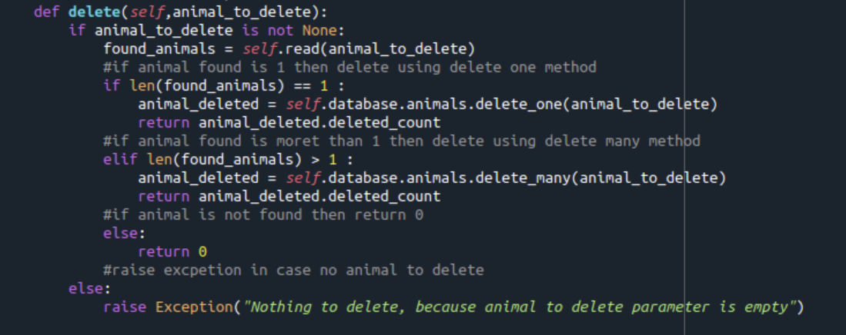

### Screenshots

*Provide screenshots that demonstrate your work.*

Verified animal shelter module

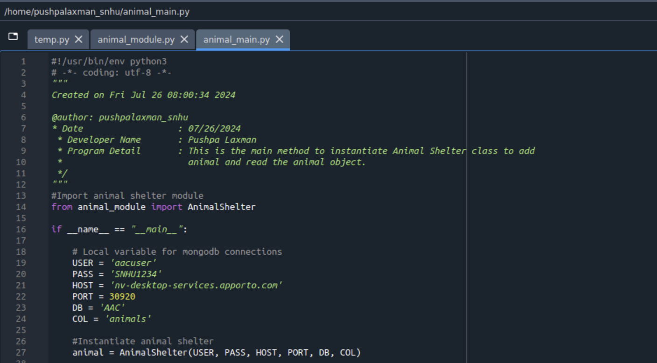

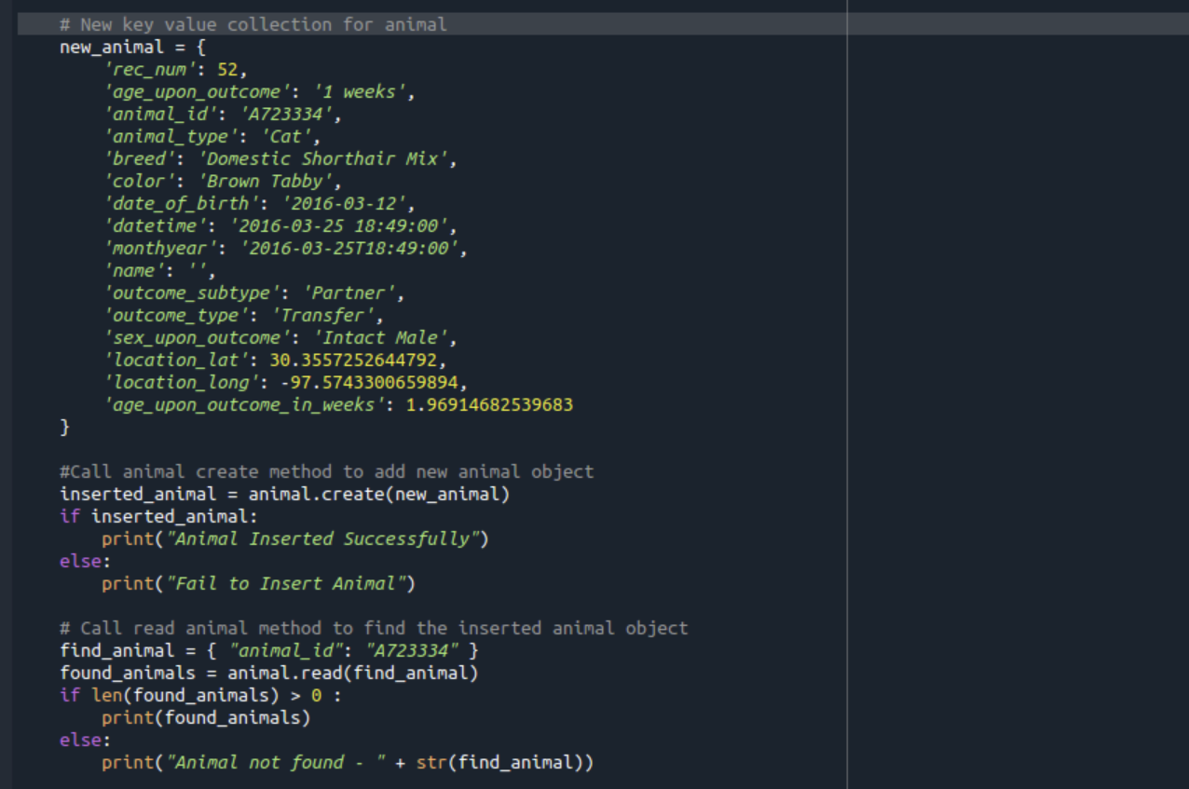

**Q. Screenshots of the CRUD functionality test execution**

You can now create the Python module which will act as a controller between the client and your database now that you have access to your database and users with access control. You can accomplish this by using the Python driver that utilizes Pymongo. In Python, Pymongo contains methods for the MongoDB CRUD operations and provides tools for interacting with MongoDB. Pymongo needs to be imported to use Mongo Client. Connections to MongoDB are made using Mongo Client. Your connection string, database, collection, username, and password are required to initialize the Animal Shelter class.

* ObjectId is imported from bson.objectid and Mongo Client is imported from Pymongo
* Use a connection string to create a Mongo Client to connect to the MongoDB instance.
* On the Mongo Client instance, declare that your database and collection will be accessed using attribute style access.

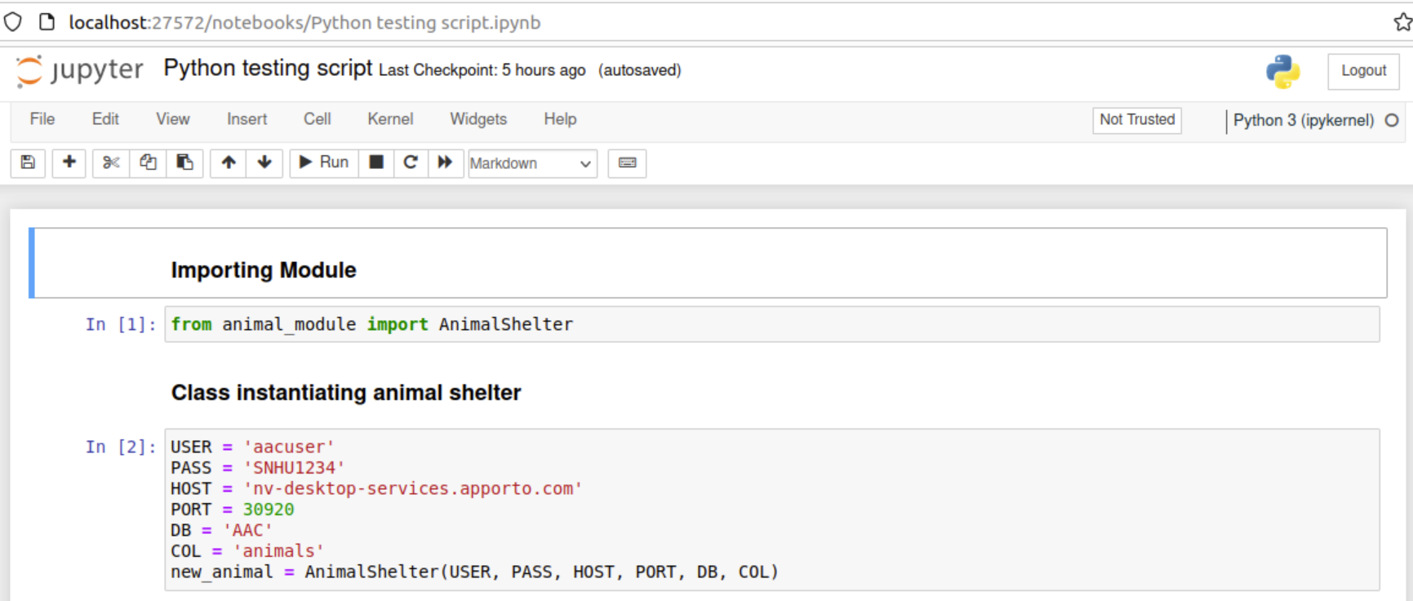

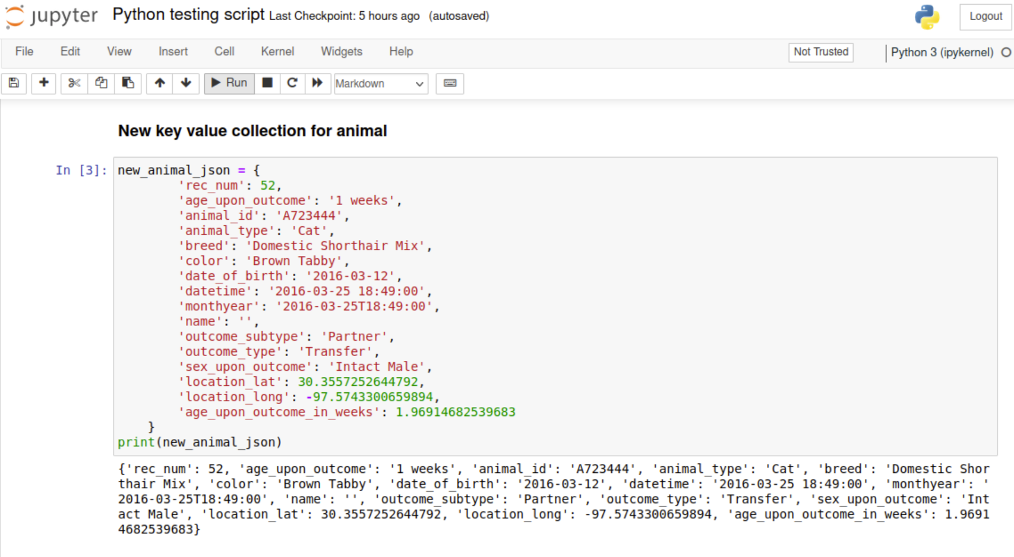

#Calling the insert method to insert the animal and also handling the exception

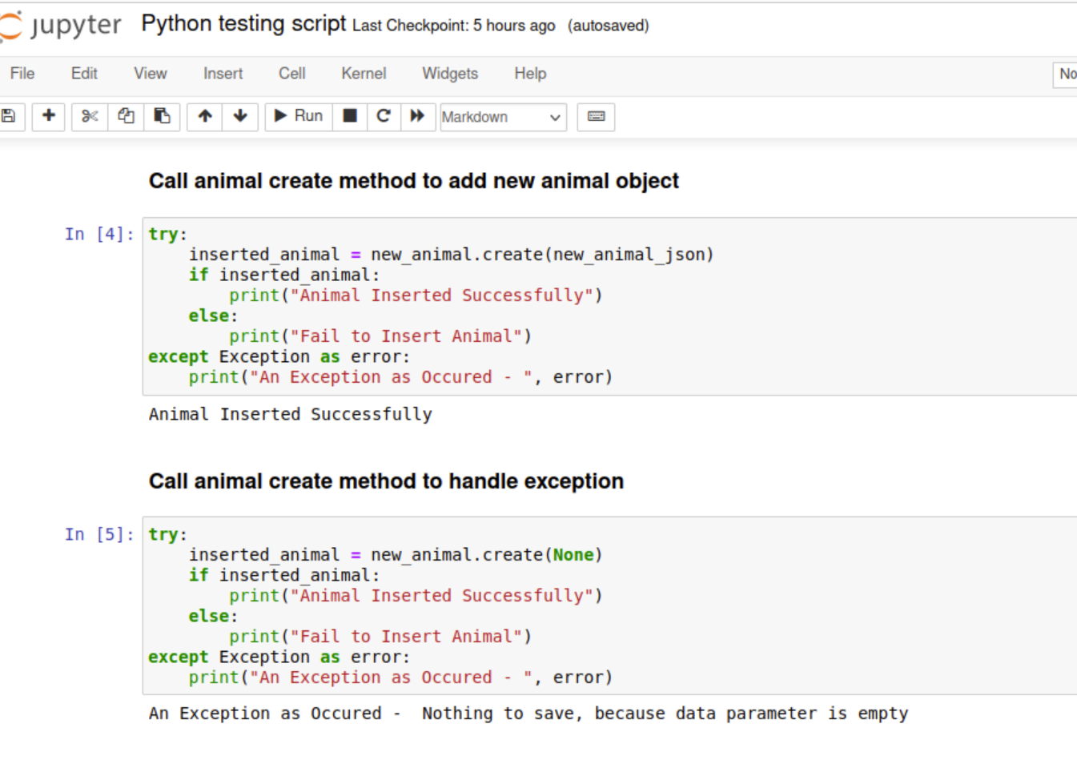

#Calling the read method to find the animal

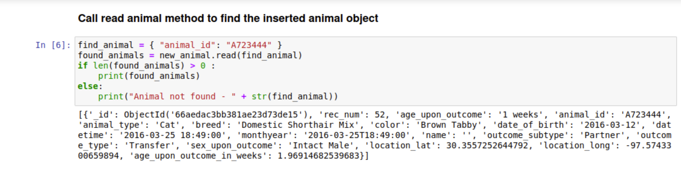

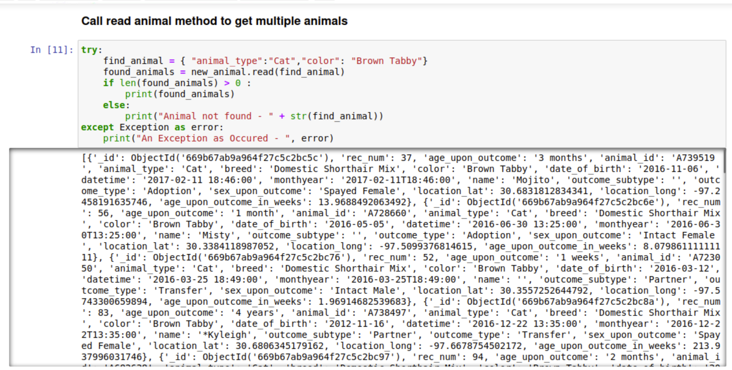

#Calling the update method to update the animal and also handling the exception

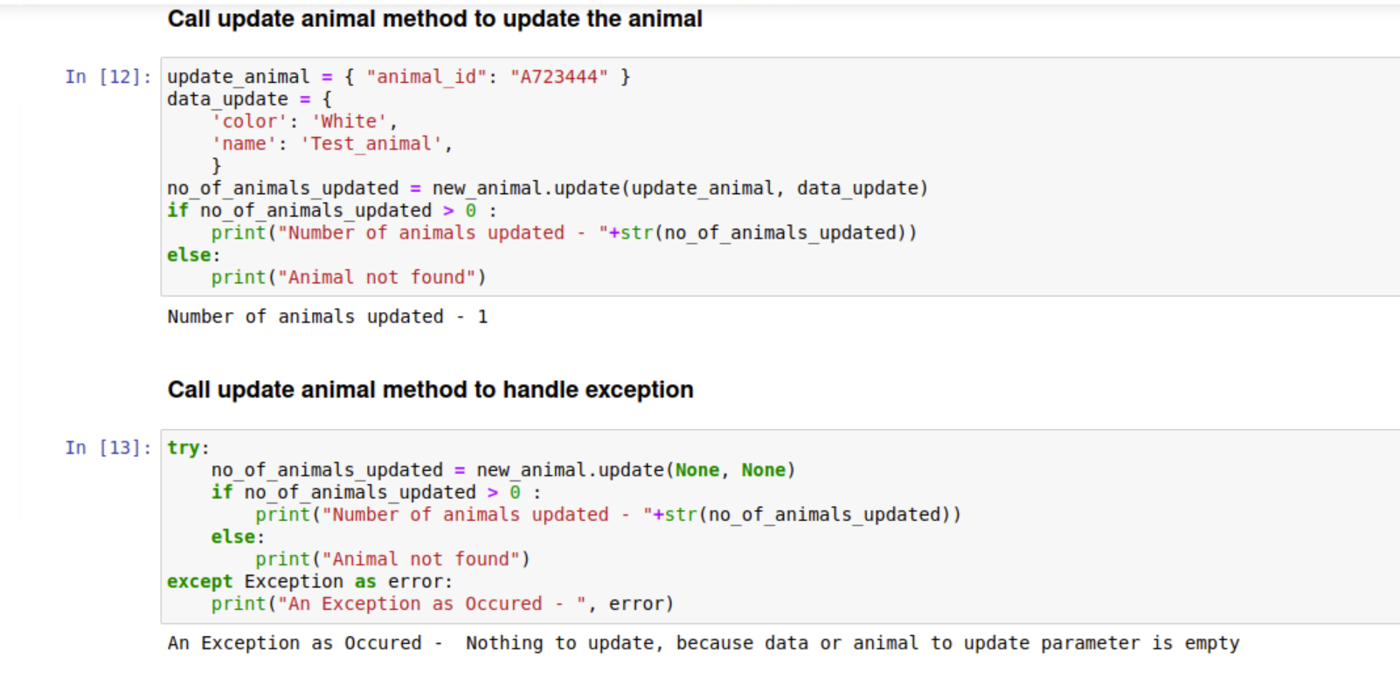

#Calling the delete method to delete the animal and also handling the exception

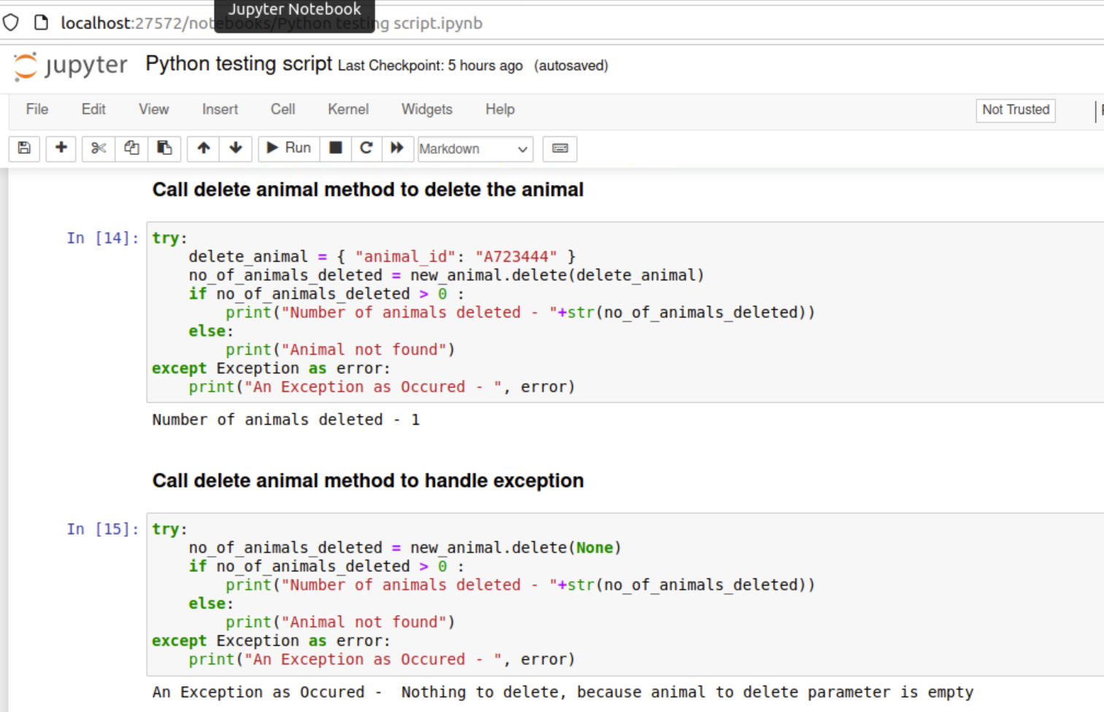

Taken screenshots or create a screencast of your dashboard and widget functionality. Each of your contain the Grazioso Salvare logo and your unique identifier. Your screenshots show the following:

The starting state of your dashboard, which should include your widgets for the interactive options to filter data (such as radio items or drop-downs), the interactive data table, and the charts

**Dashboard Branding:**

Below screenshot provides the unique identifier details with name and Logo has an anchor tag to redirect to SNHU website. When you click on the Logo, it will redirect to SNHU website.

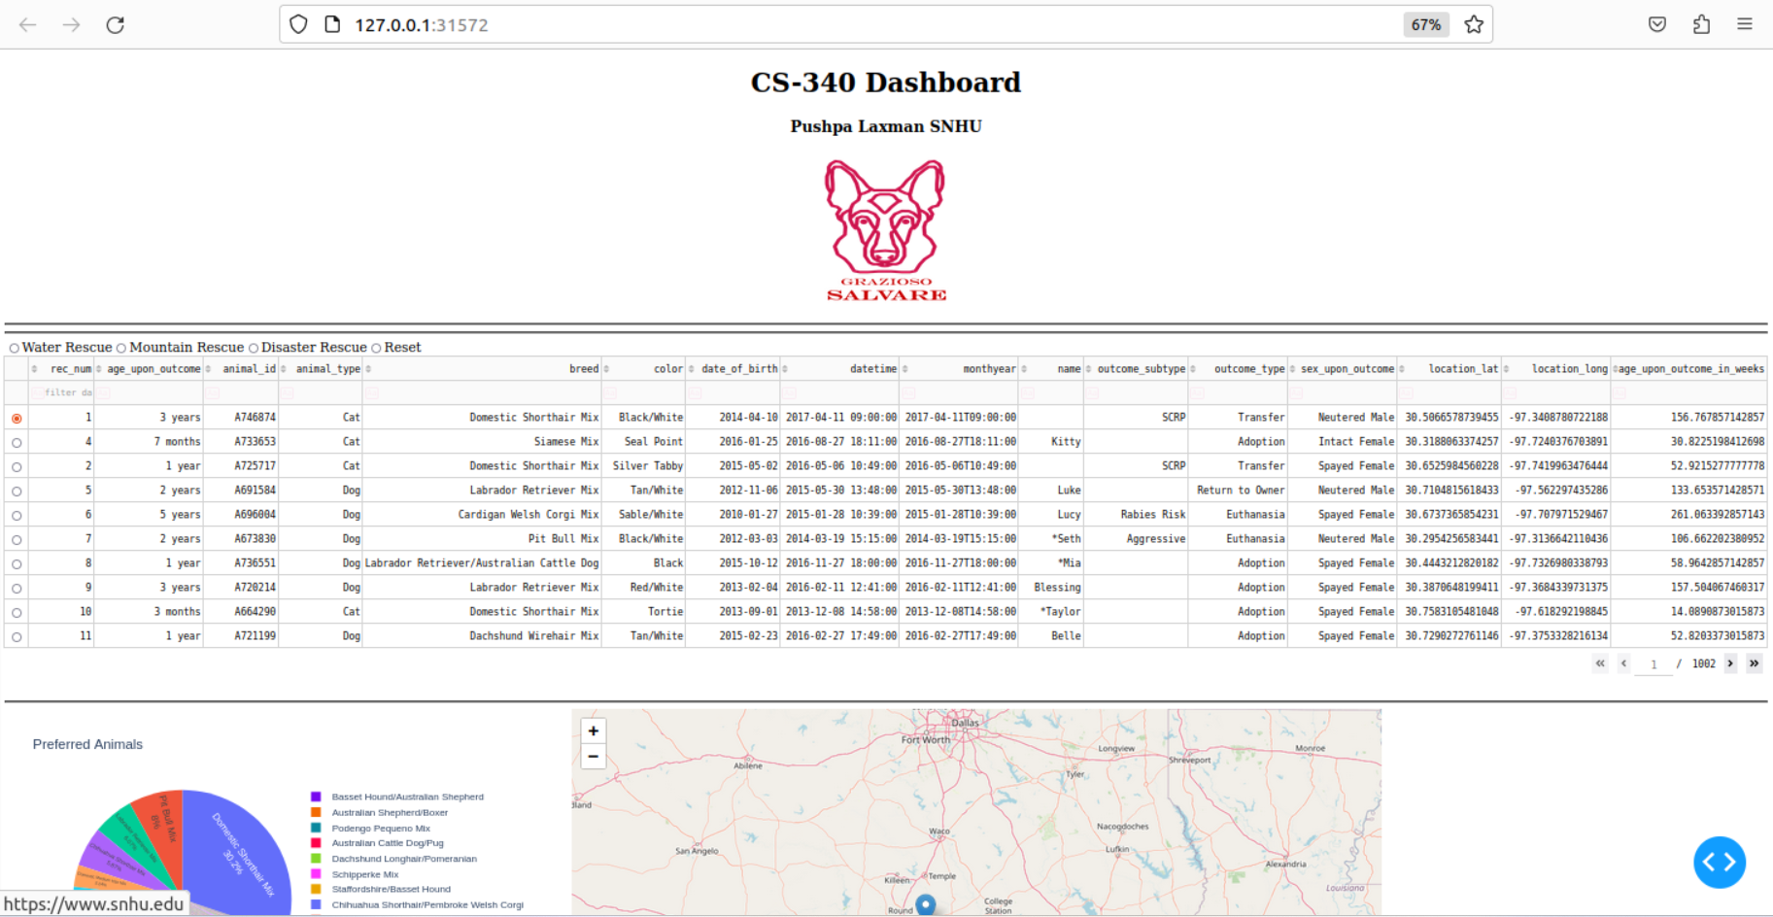

**Dashboard Widgets:**

Below screenshot displays the data table, pie chart and geolocation chart without any interactive filtering options.

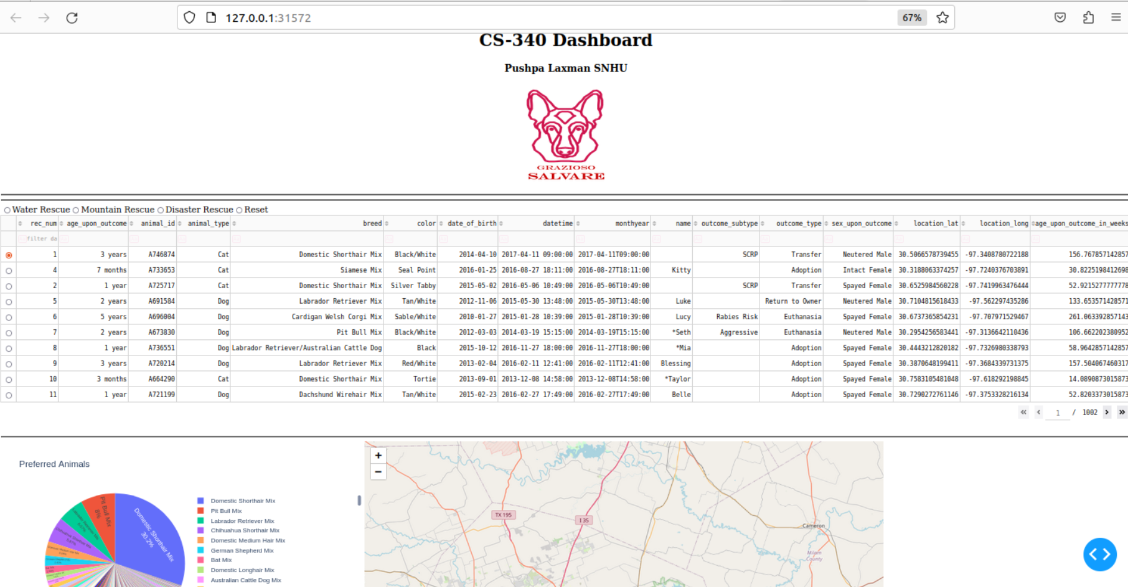

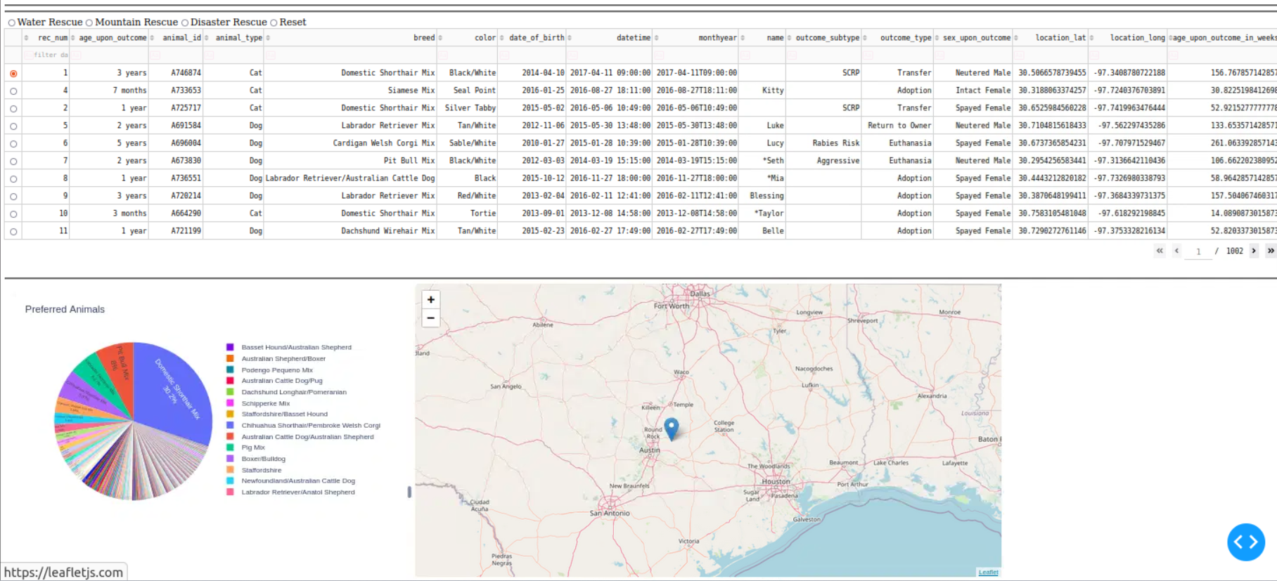

Dashboard (Python Code): CRUD Python Module Queries for Filtering:

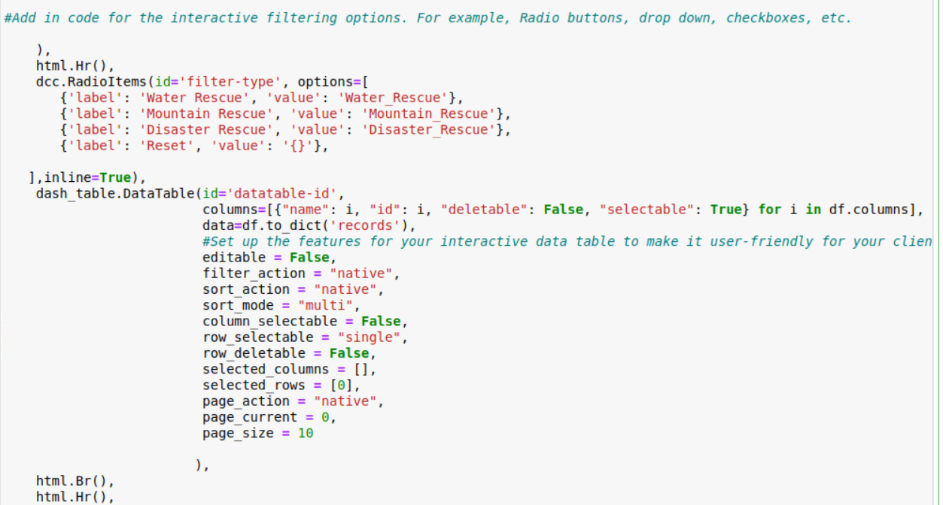

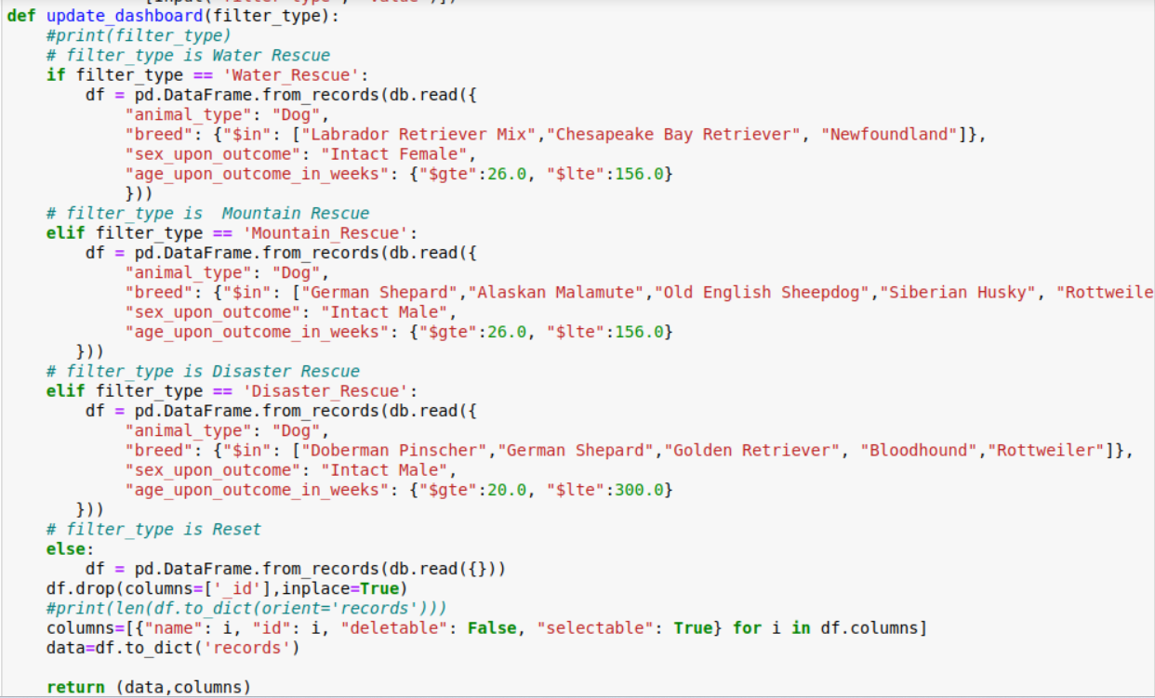

Added pie chart:

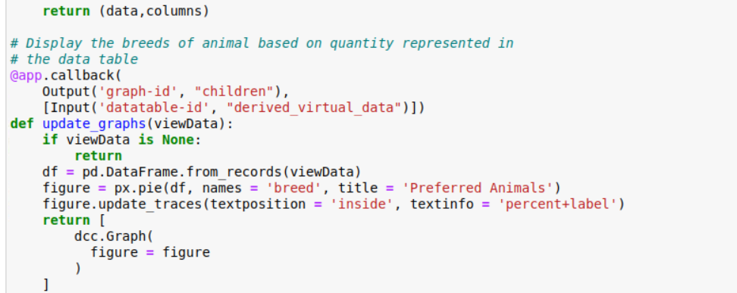

Screenshot of pynb file:  
In order to complete the dashboard, you will need to import several libraries along with your CRUD module. Once you have set up the database, you can start implementing the dashboard.

Dash Leaflet and Plotly Dash are the two libraries used to build this example's interface.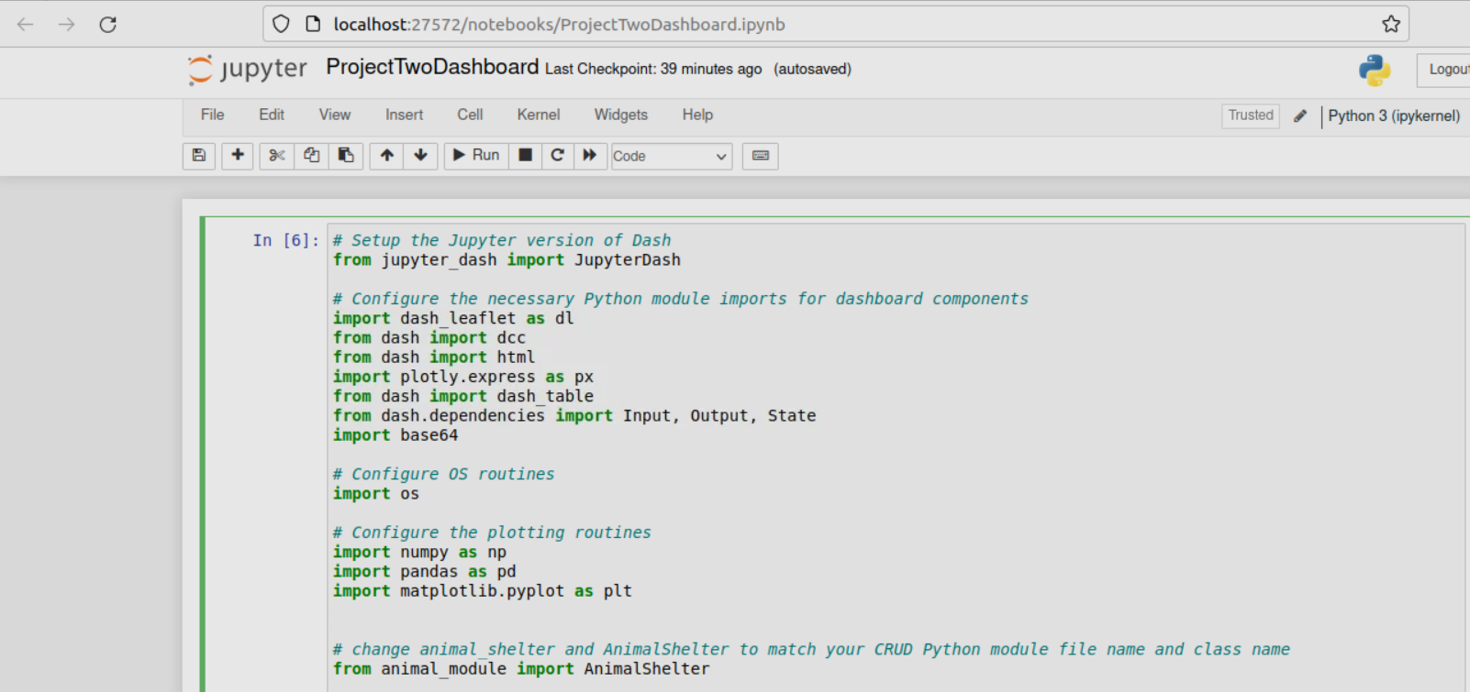

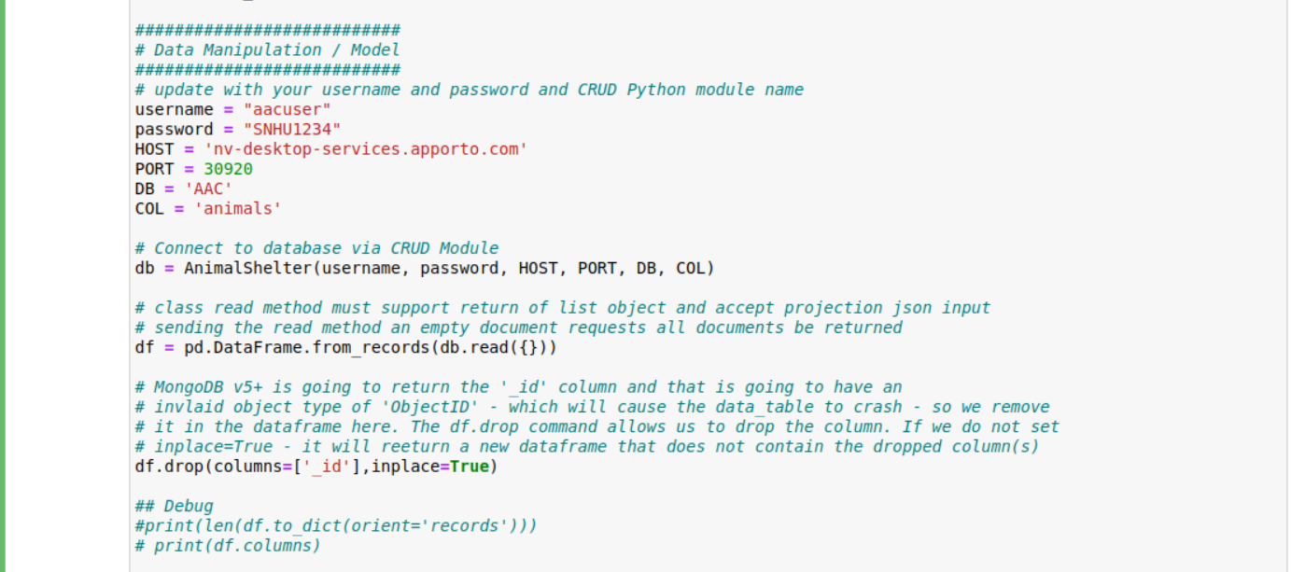

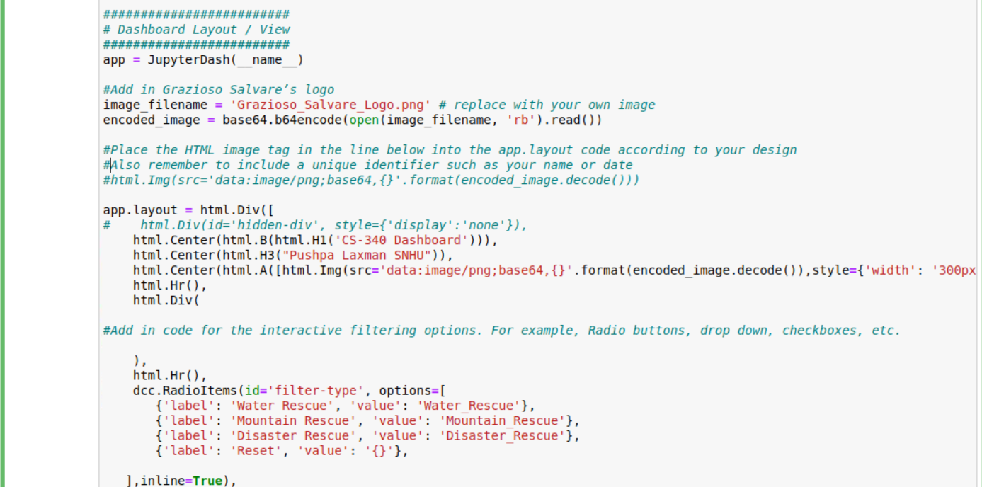

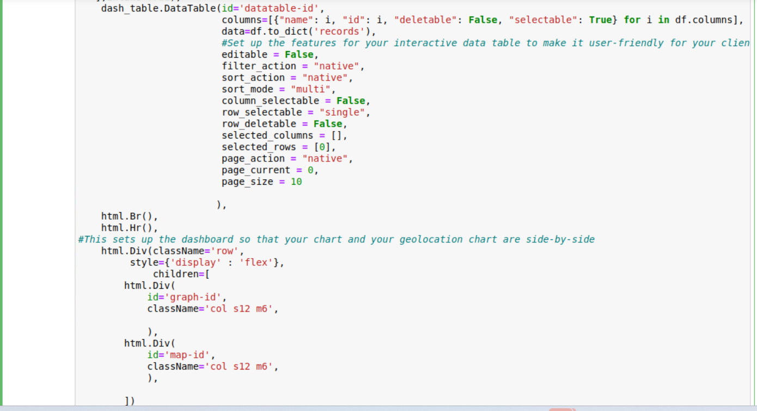

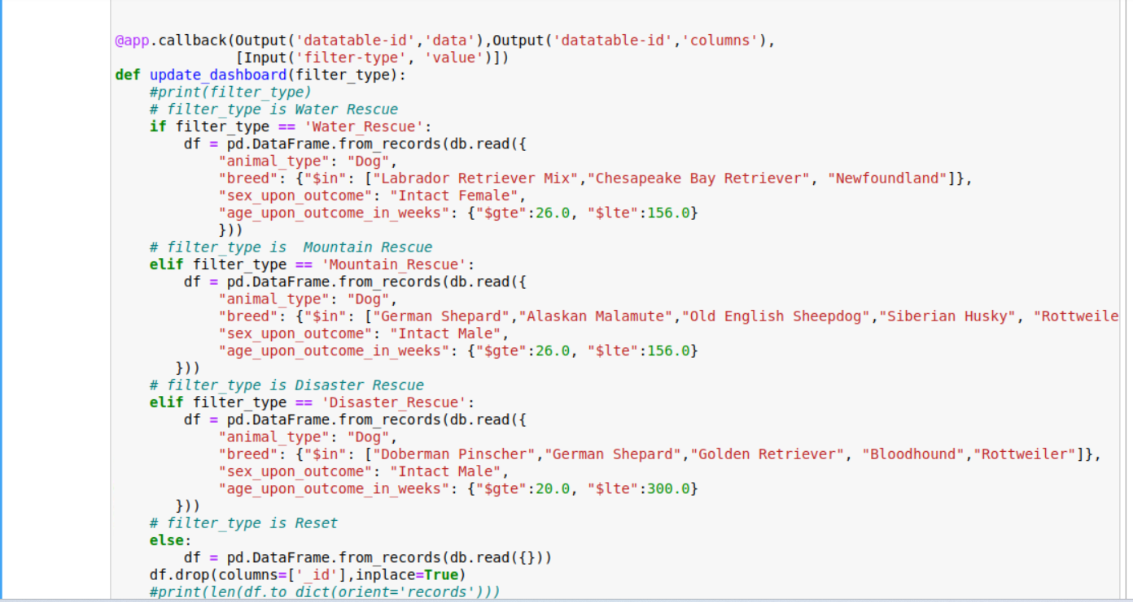

Add a geolocation chart that displays data from the interactive data table to your existing dashboard.

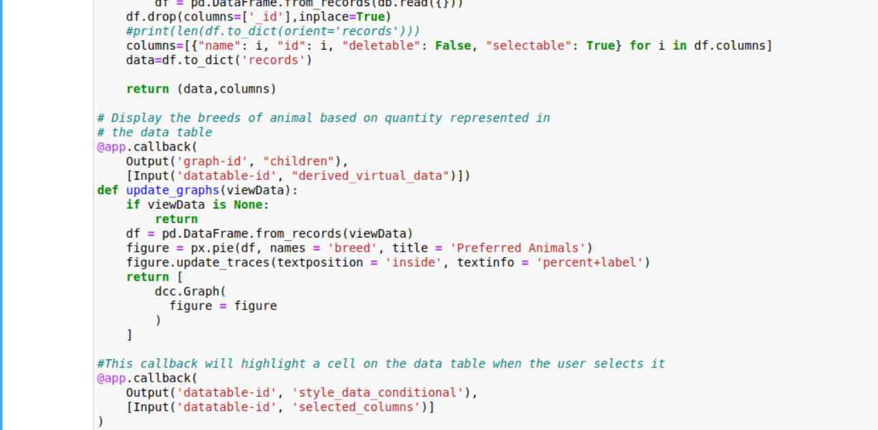

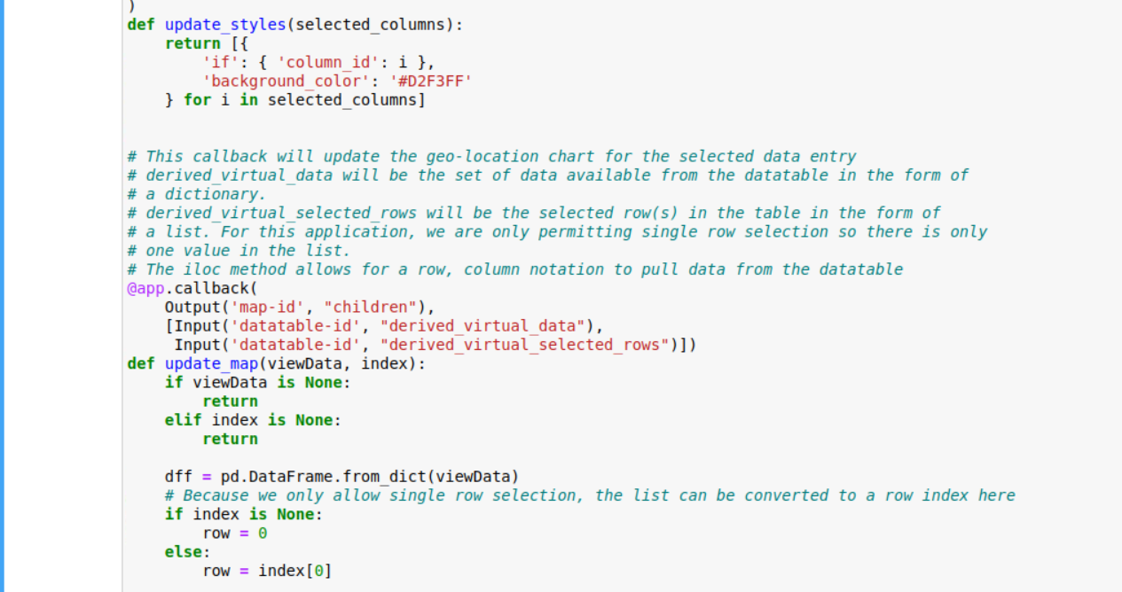

Finally, to run to application use the line app.run_server(). This will result in a link being presented in which you can click on to view your dashboard.

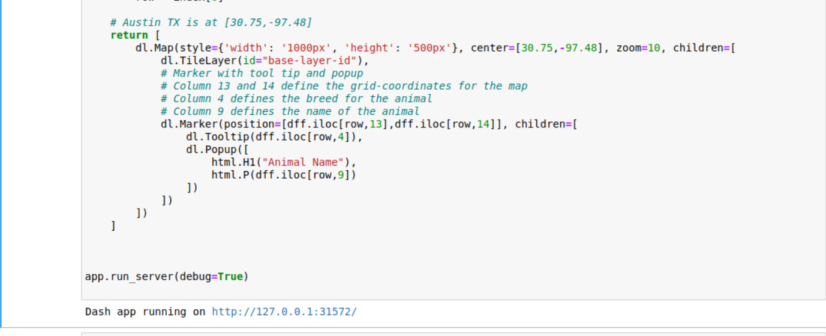

Dashboard Widgets:

Grazioso Salvare is requiring the following widgets for the dashboard interface: • Interactive filter options (buttons, drop-downs) to filter the Austin Animal Center Outcomes data set by:

**○ Water Rescue: Filtering for the water radio button**

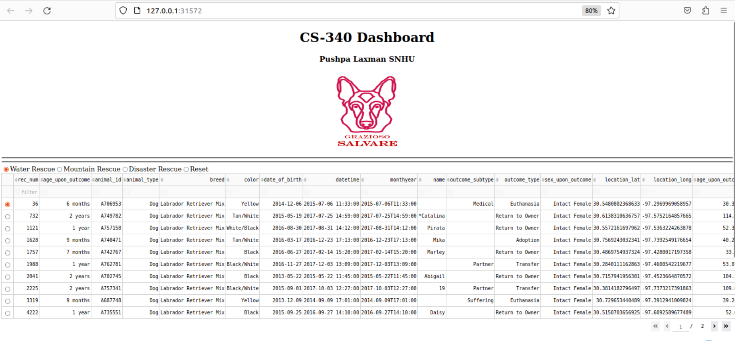

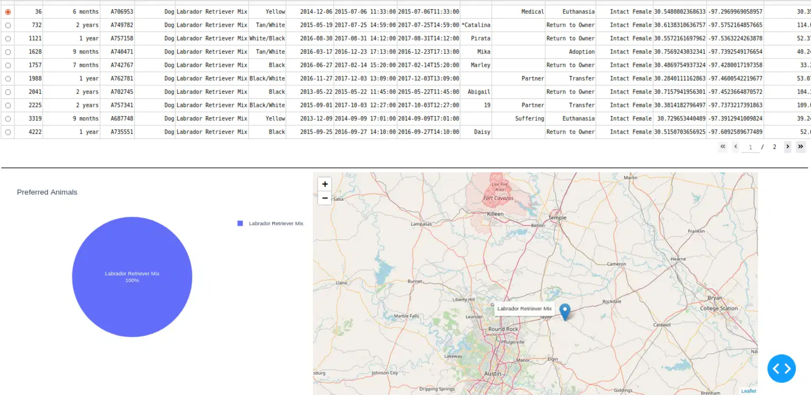

**○ Mountain or Wilderness Rescue: Filtering for the Mountain radio button**

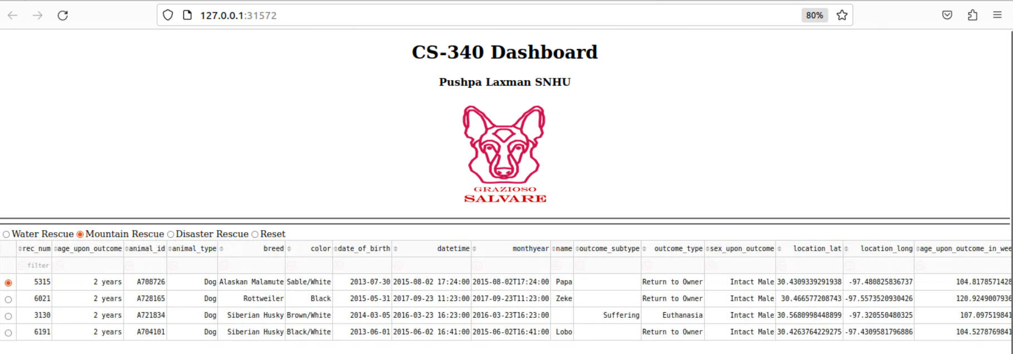

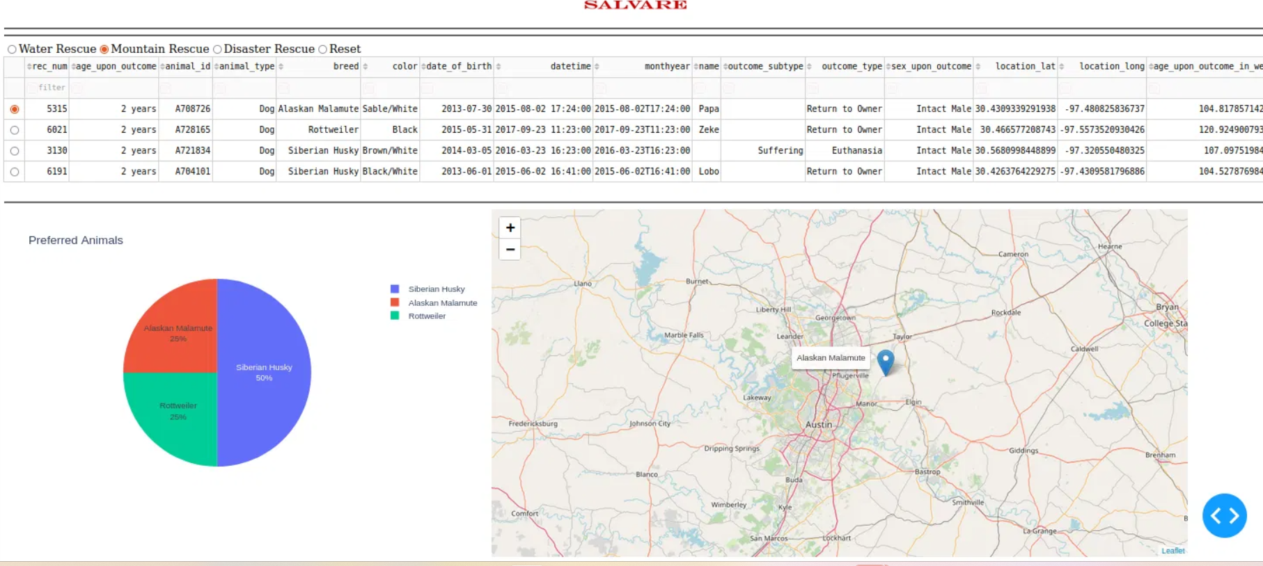

**○ Disaster Rescue or Individual Tracking: Filtering for the Disaster radio button**

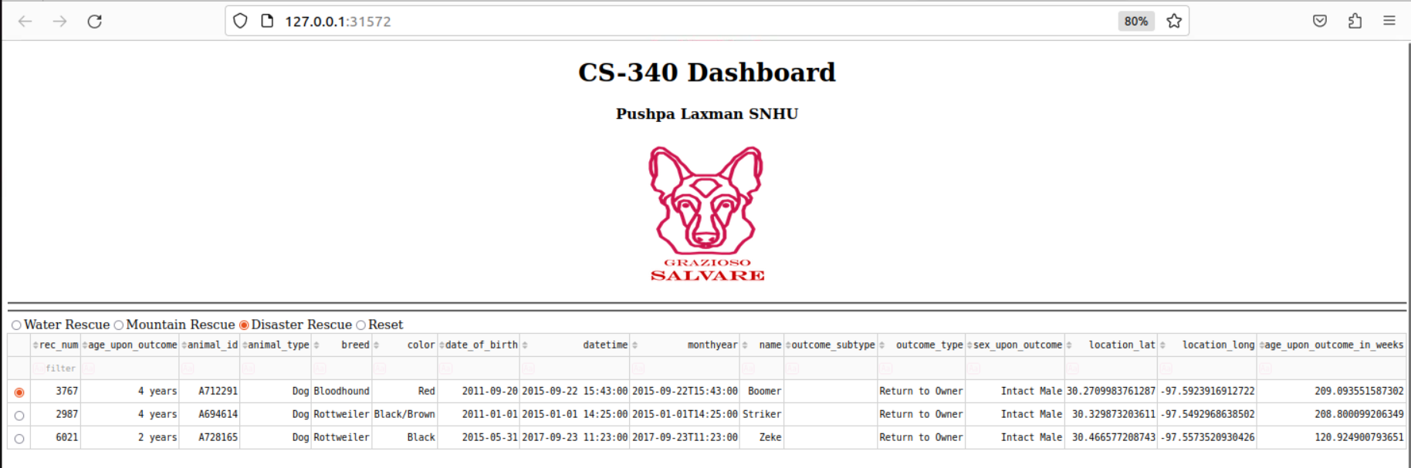

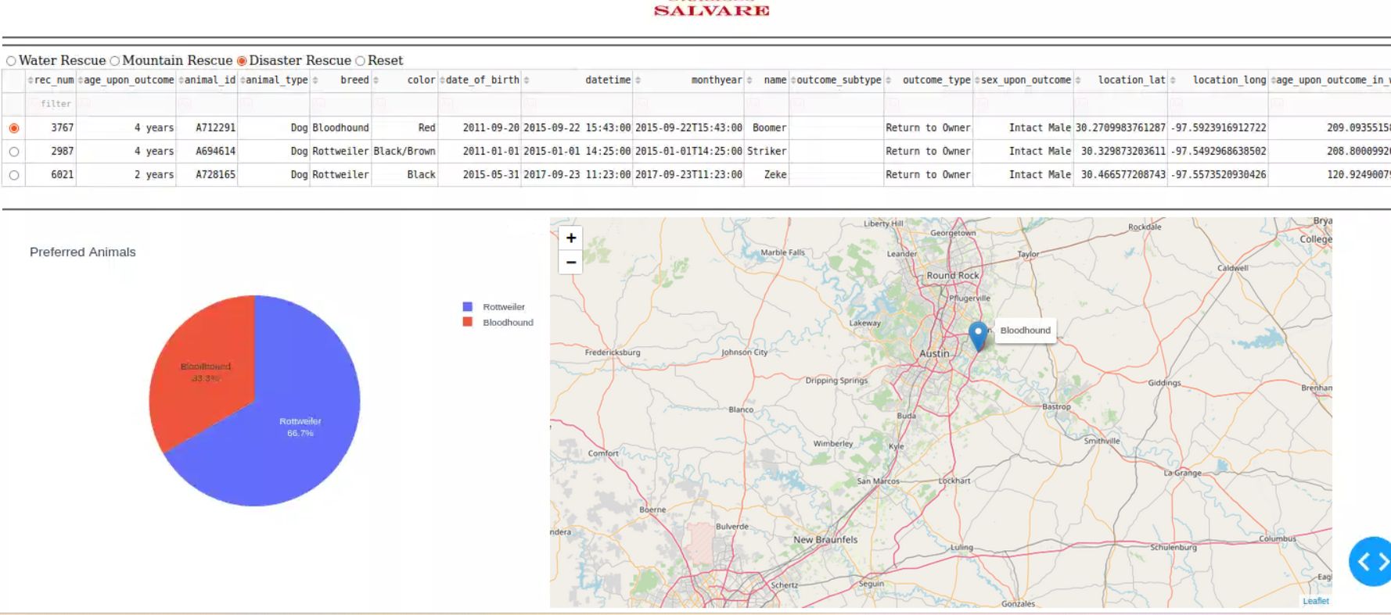

**○ Reset (returns all widgets to their original, unfiltered state)**

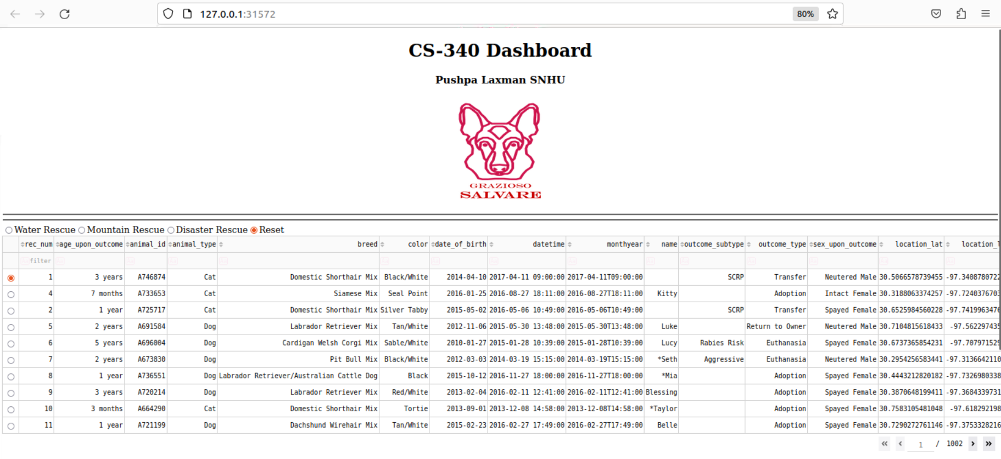

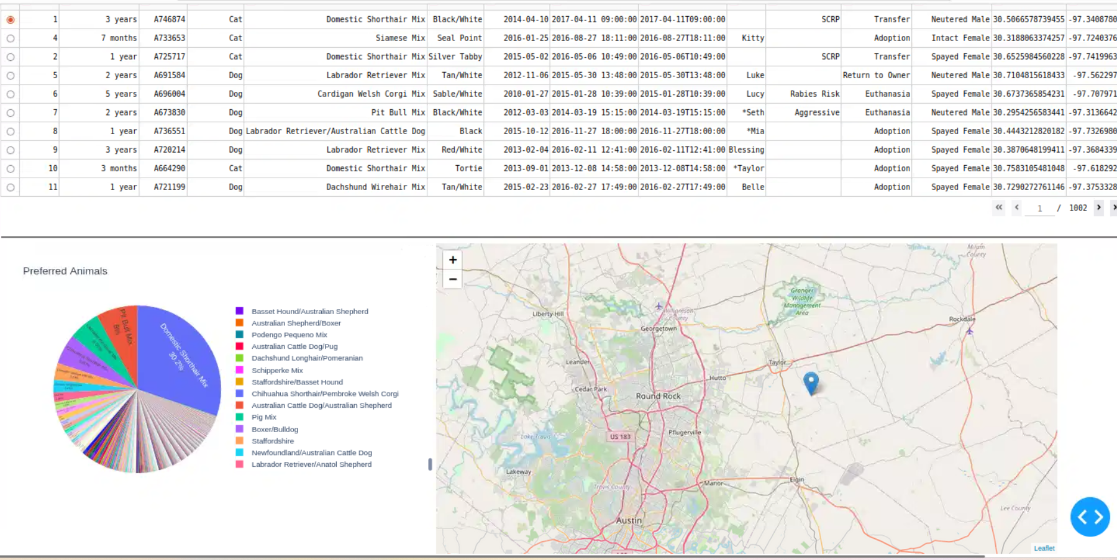

Challenges faced:

I faced several challenges while developing this application. It was the layout of the application that presented the greatest challenge for me. There were a lot of components involved in the layout and learning the syntax took some time. The dash plotly, CSS, and HTML tutorials I watched helped me overcome the challenge. As a result, the layout design became more intuitive as these all worked together. I also encountered a challenge with the button callbacks. It was difficult for me to add the correct query where the radio buttons would work for each filtering option. The comparison needed to be able to identify which button was pressed. I tried writing the query first in the dcc.RadioItems(id='filter-type') by entering the entire table with each rescue type but failed to run. Through reviewing the tutorials and resources provided in Brightspace, I was able to simplify the logic required to determine the correct callback output. It was also difficult for me to come up with appropriate search queries. Breed names for many of the breeds differ from the proposed requirements provided by Grazioso. Some queries didn't produce any results as a result, such as Chesapeake Bay Retriever. There were some names that had been shortened. In addition, there were breeds that combined two dog breeds, such as the Labrador Retriever and Australian Cattle Dog. In order to search for the correct breeds, I used regular expressions in the standard library. Additionally, I was receiving dash port errors frequently. It took me a long time to finish the work and take screenshots for each type of rescue.